NGWS Programming
by Jeffrey Richter
Special Preview for PDC Attendees:
This booklet contains 3 unedited chapters from Jeffrey Richter’s forthcoming book on
NGWS Programming

Copyright © 2000 by Jeffrey Richter (www.Wintellect.com / www.JeffreyRichter.com)

Reproduction by any means, in whole or in part, is strictly prohibited. Do not quote for review purposes without comparison to the final work.
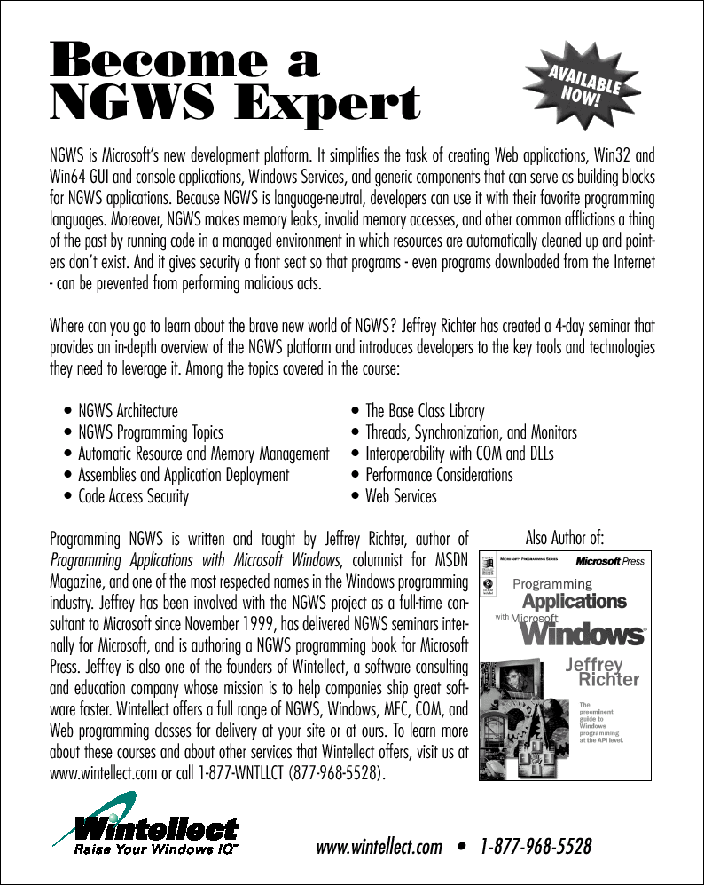

Chapter 1
NGWS Development Platform Overview
Over the years, our computing lifestyles change. Today, everyone sees the value of the Internet and our computing lifestyle is becoming more and more dependant on web-based services. Personally, I love to shop, get traffic conditions, compare products, and read product reviews all via the Internet.
However, I’m finding that there are still many things I’d like to do via the Internet that are not possible today. For example, I’d like to find restaurants in my area that serve a particular cuisine. Furthermore, I’d like to know if the restaurant has any seating available at 7PM tonight.
Or, if I had my own business, I might like to know which vendor has a particular item in stock. If multiple vendors can supply me the item, I want to know which vendor is cheapest or maybe which vendor can deliver the item to me the fastest.
There are two main reasons why services like these don’t exist today. The first reason is because there are no standards in place for integrating all this information. After all, vendors today have their own way of describing what they sell. The emerging standard for describing all type of information is XML. The second reason why these services don’t exist today is due to the complexity of developing the code necessary to integrate such service.
It should be as no surprise that Microsoft wants to help integrate services like these. To that end, Microsoft is embracing the XML standard for describing data and is providing a new development platform infrastructure that, in my opinion, will really help developers to create and deploy distributed applications on Internet time.
This platform is called NGWS. NGWS allows developers to leverage technologies more than any earlier Microsoft platform. Specifically, NGWS really delivers on code reuse, code specialization, resource management, multi-language development, security, deployment, and administration. While designing this new platform, Microsoft also felt that it is necessary to improve on some of the deficiencies of the current Windows platform. I will address many of these deficiencies in this chapter.
NGWS represents a whole new way of developing software. Note that I didn’t say “developing software for Windows.” This is because NGWS is not necessarily tied to the Windows operating system. In this chapter, we’ll discuss the NGWS architecture and describe how this new platform offers the type of leveraged technologies mentioned earlier.
At the heart of the NGWS platform is a runtime engine and a base class library. All programmers are familiar with these concepts and have been using them for years. I’m sure many of you have at least dabbled with the C-Runtime library, the standard template library, the Microsoft Foundation Class library, the Active Template library, the VB runtime library, or the Java virtual machine. In fact, the Windows operating system itself can be thought of as a runtime engine and library. Runtime engines and libraries offer services to applications and programmers love them because they save us from re-inventing the same services over and over again.
The NGWS base class library is how developers access the features of the runtime and also offers many high-level services so that developers don’t have to code and re-code the same services repeatedly. But, more importantly, the NGWS runtime engine, sitting under this library, offers the technologies to support rapid software development. The list below gives you just a small sampling of what the NGWS runtime engine provides:
- A consistent programming model. All application services are offered via a common object-oriented programming model unlike today where some OS facilities are accessed via DLL functions and other facilities are accessed via COM objects.
- Simplified programming model. NGWS seeks to greatly simplify the plumbing and arcane constructs required by Win32 and COM. Specifically, NGWS now frees the developer from understanding any of the following concepts: the registry, GUIDs, IUnknown, AddRef, Release, HRESULTS, and so on. It is important to note that NGWS doesn’t just abstract these concepts away from the developer; in the new NGWS platform, these concepts simply do not exist in any form whatsoever.
- Run once, run always. All Windows developers are familiar with “DLL Hell.” This is when installing components for a new application overwrite components of an old application causing the old application to exhibit strange behavior or stop functioning altogether. The NGWS architecture now separates application components so that an application always loads the components that it was built and tested with. If the application runs after installation, then the application should always run. This marks the end of “DLL Hell”.
- Write one, build once, and broad execution. Today, there are many different flavors of Windows: Windows 95/98/98SE/98ME, Windows NT4/2000 (with various service packs), Windows CE and soon, a 64-bit version of Windows 2000. Most of these systems run on x86 CPUs but Windows CE and 64-bit Windows run on non-x86 CPUs. Once written and built, a managed NGWS application (that consists entirely of managed code) can execute on any platform that supports the NGWS runtime. It is even possible that a version of the runtime could be built for non-Windows platforms in the future. End-users will immediately appreciate the value of this broad execution if they ever change their computing hardware or operating system.
- Programming language integration. COM allows different programming languages to interoperate with one another. NGWS allows languages to be integrated with one another. For example, it is possible to create a class in C++ that derives from a class implemented in Basic. NGWS allows this because it defines and provides a type system that is common among all NGWS languages. Microsoft produces a Common Language Specification (discussed later in this chapter) that describes what compiler implementers must do in order for their languages to integrate well with other languages. Microsoft is providing several compilers that produce code targeting the NGWS runtime: C++ with managed extensions, C♯ (pronounced: C Sharp), Visual Basic (which now subsumes VBScript and Visual Basic for Applications), and JScript. In addition, companies other than Microsoft are producing compilers for other languages that also target the NGWS runtime.
- Code reuse. Using the mechanisms described above, you can create your own classes offering services to third party applications. This, of course, makes it extremely simple to reuse code. This also creates a large market for component vendors.
- Automatic memory and resource management. Programming requires great skill and discipline. This is especially true when it comes to managing the use of resources like files, memory, screen space, network connections, database resources, and so on. One of the most common bugs is neglecting to free one of these resources, ultimately causing the application to perform improperly at some unpredictable time. The NGWS runtime automatically tracks resource usage guaranteeing that your application never leaks resources. In fact, there is no way to explicitly “free” a resource. In chapter 3, I’ll explain exactly how this works.
- Type safety. The NGWS runtime can verify that all your code is type safe. Type safety ensures that allocated objects are always accessed in compatible ways. Hence, if a method input parameter is declared as accepting a 4 byte value, the runtime will detect and trap attempts to access the parameter as an 8 byte value. Similarly, if an object occupies 10-bytes in memory the application can’t coerce this into a form that will allow more than 10-bytes to be read. Type safety also means that execution flow will only transfer to well-known locations (i.e., method entry points). There is no way to construct an arbitrary reference to a memory location and cause code at that location to start executing. Together, these eliminate many common programming errors and classic system attacks (e.g, exploiting buffer overruns).
- Rich debugging support. Since the NGWS runtime is used for many languages, it is now much easier to implement portions of your application using the language best suited. The NGWS runtime fully supports debugging applications that cross language boundaries. The runtime also provides built-in stack-walking facilities making it much easier to locate the location of bugs and errors.
- Consistent error handling paradigm. One of the most aggravating things of Windows programming is the inconsistent styles used for error reporting. Some functions return Win32 error codes, some functions return HRESULTS, and some functions raise exceptions. In NGWS, all errors are reported via exceptions – period. Exceptions allow the developer to isolate the error handling code from the code required to get the work done. This greatly simplifies writing, reading, and maintaining code. In addition, exceptions work across module and programming language boundaries as well.
- Deployment. Today, Windows applications are incredibly difficult to set up and deploy. There are usually several files, registry settings and shortcuts that need to be created. In addition, completely uninstalling an application is nearly impossible. With Windows 2000, Microsoft introduced a new installation engine that helps with all of these issues but it is still possible that a company authoring a Microsoft Installer Package may fail to do everything correctly. NGWS seeks to banish these issues into history. NGWS components are no longer referenced in the registry. In fact, installing most NGWS -based applications will require no more than copying the files to a directory and uninstalling an application will be as easy as deleting those files.
- Security. Traditional OS security provides isolation and access control based on user accounts. This has proven to be a useful model, but at its core assumes that all code is equally trustworthy. This assumption was justified when all code was installed from physical media (e.g., CD-ROM) or trusted corporate servers. But, with the increasing reliance on mobile code such as Web scripts, applications downloaded over the Internet, and e-mail attachments we need ways to control the behavior of applications in a more fine-grained manner. NGWS Codes Access Security (discussed later) provides a means to do this.
Microsoft also recognizes that many applications want to enforce behaviors based on a concept of ‘roles’ as opposed to individual accounts. Microsoft initially delivered support for this concept with MTS, and provided further enhancements with COM+ 1. In NGWS, Microsoft supports the deployment of application-defined roles and access control based on these roles. These mechanisms are extended in ways that accommodate the Internet and heterogeneous environments.
As you might imagine, addressing all these issues requires an architecture consisting of several pieces. Let’s go through the process of developing and deploying an application together. Our first step is to determine what type of application we intend to build. For this discussion, let’s just assume that we’ve already solved this minor detail, the application is designed, the specs are written, and we’re ready to start development.

Languages
Our application consists of several different subcomponents. To make development easier, we realize that certain programming languages are best tailored to handle specific tasks. In addition, some of the developers on our team prefer working in C++ while other developers prefer Pascal. In NGWS, the language you select for any given task is totally up to you and is simply a matter of personal choice.
As far as the NGWS runtime is concerned, all languages are equal. Now it’s true, some languages offer certain features over other languages but these features are language features, not runtime features. For example, the NGWS runtime supports the creation and manipulation of threads. Since this is a runtime feature, any language that targets the runtime will be able to create and manipulate threads.
On the other hand, Visual Basic is specifically designed to prevent programmers from shooting themselves in the foot. One way that Visual Basic does this is by treating all variables, function names, and so on as case-insensitive symbols. This “feature” of Visual Basic is purely a language issue and has no bearing on the Runtime at all.
Microsoft is creating four language compilers that target the runtime: C++ with managed extensions, C♯, Visual Basic, and JScript. By default, Microsoft’s Visual C++ compiler builds an executable or DLL that does not target the runtime. However, by specifying a new command-line switch, the Visual C++ compiler produces code that targets the runtime. The term managed code describes code that requires the runtime execution engine. The term unmanaged code describes code that does not require the runtime engine.
Of the four Microsoft compilers mentioned, Visual C++ is the only one capable of producing unmanaged code. The other compilers, C♯, Visual Basic and JScript, can only produce managed code and therefore code written in these languages absolutely requires the runtime engine in order to execute. In addition to Microsoft, there are several companies producing compilers that generate managed code. I am aware of compilers for APL, CAML, Cobol, Haskell, Mercury, ML, Oberon, Oz, Pascal, Perl, Python, Scheme, and Smalltalk. In fact, Rational is creating a Java compiler that targets the NGWS runtime.

Assemblies (Managed Components)
After we create our source code files, we run them through the respective compilers, and the result is an EXE or DLL. These EXE/DLL files are very similar to the PE files that we’ve become familiar with over the years – in fact, they are valid PE files -- with just a few differences.
One difference is the code in managed PE files generated by our language compilers is not x86 machine code or machine code targeted to any specific CPU platform. Instead, the code generated by the compiler is an intermediate language called IL. IL is discussed in more detail in a later section.
Another difference is that the file contains metadata emitted by the compiler that is used by the runtime to locate and load class types in the file, lay out object instances in memory, resolve method invocations and field references, translate IL to native code, enforce security, and perform a whole slew of additional features. Metadata is also discussed in more detail in a later section.
There’s another difference, too. That is that the components that you as a developer are producing are not just EXEs or DLLs. Rather, the unit of reuse and deployment in NGWS is an assembly. Depending on the choices you make in your compiler or tool, you might be producing a single-file assembly or you might be producing a managed code module that is intended to be deployed as a part of a multi-file assembly. Think of an assembly as a logical EXE or DLL. In fact, since in the single-file assembly case the assembly carries an .exe or .dll extension, you might ask what the point was of introducing a new concept. The point, very precisely, is that by decoupling the logical and physical notions of a reusable component, you get to partition your code into multiple files as an implementation choice (e.g., to get benefits of incremental and on-demand download) while still establishing the collection as a single unit of versioning and deployment.
From an assembly consumer’s perspective (the external view), an assembly is a named and versioned collection of exported types and resources. From an assembly developer’s perspective (the internal view), an assembly is a collection of one or more files – from a single PE file to a collection of PE files, resource files, html pages, gifs, etc. – that implement types and resources.
The components of an assembly are described in a manifest. A manifest is a block of data that enumerates the assembly’s files, controls what types and resources are exposed outside of the assembly – for example, some types may be reserved for use only within the assembly while others may be exported to consumers of the assembly – and governs how references to these types and resources are mapped onto the files that contain their declarations and implementations. The manifest also enumerates other assemblies on which this one is dependent. The existence of a manifest provides a level of indirection between consumers of the assembly and the implementation details of the assembly and makes assemblies self-describing.
Every module loaded at runtime is loaded in the context of an assembly. Every type that is loaded is scoped in an assembly scope – that is to say, part of the identity of a type is its assembly identity. A type Foo loaded in the scope of one assembly is not the same type Foo loaded in the scope of another assembly even if a hash of their declarations and implementations were exactly the same.
You as a developer will be making explicit choices at development time. If you import a type from another assembly, your own file’s metadata will contain references to that assembly -- the compiler will put them there. If you import a type from an individual module within a multi-file assembly, your own file will contain an explicit dependency on that module – again, the compiler will put it there. In the latter case, NGWS will enforce at runtime that you and that module are, in fact, built as part of the same assembly, thus honoring and enforcing assembly boundaries.
The Microsoft languages and compilers make it easy to make these decisions by providing reasonable defaults for the typical case and by providing directives and tools – such as the Assembly Linker utility, AL.exe, that aid in building multi-file assemblies.
Assemblies are the basis for the deployment and versioning features of NGWS. Assemblies allow developers and administrators to express strict version dependencies between pieces of an application and, because they are self-describing, help enable the notion of zero-impact install. Assemblies also play a role in the NGWS security system in that the assembly is the unit at which permissions are requested and granted. To properly enforce the versioning, deployment and security features in NGWS, the assembly acts as the resolution scope that is used to resolve references to types. NGWS honors the rules expressed in the assembly manifest for resolving types and resources to their implementation files within an assembly and for binding to dependent assemblies.

System Services
Included with NGWS is a base class library assembly that contains several class definitions where each class exposes some feature of the underlying platform. Since Microsoft defines literally hundreds of classes in the base library, the library is divided into namespaces which group related classes together.
For example, the System namespace (which you should become most familiar with) contains the base class, Object, which all other classes ultimately derive from (I’ll mention more about this later). In addition, the System namespace contains classes for exception handling, garbage collection, console I/O, as well as a bunch of utility classes that convert safely between data types, format data types, random number generators, and various math functions.
Here is a small sampling of some of the other namespaces included in the base class library:
Namespace | Description | Example classes
System | Contains all the basic types used by every application | Object, Buffer, Byte, Char, Array, Int32, Exception, GC, String
System.Collections | Contains types for managing collections of Objects | ArrayList, BitArray, Dictionary, Hashtable, Queue, SortedList, Stack
System.Data | Contains basic database management types | DataBinding, DataRelation, DataRow, DataSet, DataTable, DataSource
System.Globalization | Contains types for NLS support, String compares, and Calendars | Calendar, CultureInfo, JulianCalendar, NumberFormatInfo, NumberStyles, RegionInfo
System.IO | Contains types that allow synchronous and asynchronous reading and writing to data streams | ByteStream, File, FileStream, MemoryStream, Path, StreamReader, StreamWriter
System.Net | Contains types that allow for network communications | WebRequest, WebResponse, TcpClient, TcpListener, UdpClient, Sockets
System.Reflection | Contains types that allow the inspection of metadata | Assembly, ConstructorInfo, FieldInfo, MemberInfo, MethodInfo, Module, ParameterInfo
System.Runtime.Remoting | Contains types that allow for managed remote objects | ChannelServices, RemotingServices, IMessage, ImessageSink
System.Security | Contains types that enable security features | Permissions, Policy, Principal, Util, Cryptography
System.Web.UI.WebControls | Contains types that enable rich user-interface controls for web-based applications | AdRotator, BorderStyle, DataGrid, HyperLink, ListBox, Panel, RadioButton, Table
System.WinForms | Contains types that enable rich user-interface controls for desktop applications | Button, CheckBox, DataGrid, FileDialog, Form, ListBox, MainMenu, MonthCalendar, NewFontDialog, RichEdit, ToolBarTreeView
Most of the namespaces listed above show “lower-level” classes. However, the base class library also includes namespaces for building rich user-interface applications. For example, the System.Web.UI.WebControls and System.WinForms namespaces includes classes that allow for very rich user-interfaces in both web-based and non-web-based applications. All in all, NGWS and the base class library allow developers to build the following application types: web services, Win32 GUI applications, Win32 CUI applications, services (controlled by the Service Control Manager), compilers and tools, personal tier applications, and components.
To access any of the platform’s features, you need to work with these namespaces and their defined classes. If you wish to customize any class’s behavior, you can simply derive your own class from the desired base library class.
The object-oriented nature of the platform is how NGWS presents a consistent programming paradigm to software developers. Also, developers can easily create their own namespaces containing their own classes. These namespaces and classes merge seamlessly into the programming paradigm greatly simplifying software development when compared to classic Windows’ programming paradigms.

Intermediate Language, the Runtime Execution Engine, and JIT Compilers
As stated earlier, compiling your source code causes the compiler to emit IL. IL is a CPU-independent machine language created by Microsoft after consultation with several external commercial and academic language/compiler writers. IL is much higher-level than most CPU machine languages. IL understands object types and has instructions that create and initialize objects, call virtual methods on objects and manipulate array elements directly. It even has instructions that raise and catch exceptions for error handling.
Like any other machine language, IL can be written in assembly language and Microsoft does provide an IL assembler, ILAsm.exe. (Microsoft also offers an IL disassembler, ILDasm.exe) The important thing to note about IL is that it is not tied to any specific CPU platform. This means that a PE file containing IL can run on any CPU platform as long as the operating system running on that CPU platform hosts the NGWS runtime engine. Initially, Microsoft will offer the NGWS runtime engine on the various flavors of Windows 95, Windows 98, Windows NT 4, Windows 2000 (both 32-bit and 64-bit), and Windows CE.
Another benefit of IL is that it provides a hardware abstraction layer. While the initial release of the runtime will only run on 32-bit Windows platforms, developing an application using managed IL sets up a developer to be more independent of the underlying operating system. For example, IL will help make code portable to 64-bit versions of Windows when the runtime is available. Finally, IL is a very important aspect of the NGWS security story since verification (discussed later) is capable of examining the code’s intention regardless of what high-level language was used to generate the code.
Today, when you build a managed executable, the module imports a function (called _CorExeMain) from the NGWS runtime’s execution engine (MSCorEE.dll). When the user invokes the executable, the operating system loader loads MSCorEE.dll and jumps to an unmanaged entry-point inside the executable module. The code in the executable module is a small stub (6 bytes on x86) that simply jumps to the _CorExeMain function contained inside MSCorEE.dll. Once the runtime engine has initialized, the engine locates the executable module’s managed entry-point and then starts executing the executable module’s managed IL code.
In the future, operating system loaders will be modified to look specifically for modules containing managed IL code. When the OS loader detects a module with managed code, the unmanaged stub entry-point will no longer be necessary and the runtime’s execution engine will simply be able to jump to the executable’s managed entry-point.
Of course, the IL instructions cannot be executed directly by today’s host CPUs. So, the runtime engine must first compile the managed IL instructions into native CPU instructions. The process is shown in figure 1. (Note that other parts of the figure are described later in this chapter).
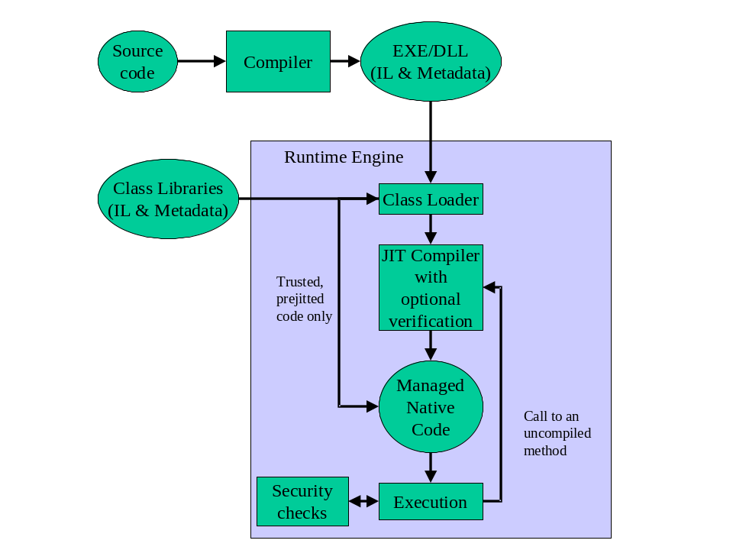
There are several questions that come up here. For example, should the runtime convert all of the file’s IL code to CPU instructions at load time? Doing so has the advantage that the program runs very fast. However, the disadvantage is that compiling the IL requires time and this would significantly hurt the application’s initialization time. In addition, very rarely does a user cause an application to execute all of its code. If the runtime compiles all of the IL to CPU instructions, then it is likely that a lot of memory and time would be wasted.
I think we all agree that it would be much more efficient to have the runtime compile the IL instructions as various functions are being called. When the runtime loads a class type, it connects stub code to each method. When a method is called, the stub code directs program execution to the component of the runtime engine that is responsible for compiling the method’s IL into native code. Since the IL is being compiled Just-In-Time, this component of the runtime is frequently referred to as a JITter or JIT Compiler. Once the JIT compiler has compiled the IL, the method’s stub is replaced with the address of the compiled code. Whenever this method is called in the future, the native code will just execute and the JIT compiler will not have to be involved in the process. As you can imagine, this helps performance considerably.
The runtime ships with two JIT compilers, the normal compiler and an economy compiler. The normal compiler examines a method’s IL and optimizes the resulting native code just like the back-end of a normal, unmanaged C/C++ compiler. The economy JIT compiler is typically used on machines where the cost of using memory and CPU cycles is high (e.g. many Windows CE devices). The economy compiler simply replaces each IL instruction with its native code counterpart. As you can imagine, the economy compiler compiles code much faster than the normal compiler however the native code produced by the economy compiler is significantly less efficient. The economy compiler will still produce code that executes much faster than interpreted code.
When the runtime is ported to a new CPU platform, Microsoft first creates the economy jitter for that platform. Since the economy jitter is relatively easy to implement, this allows NGWS applications to run on the new CPU platform in a very short period of time. Once the economy jitter is complete, Microsoft then spends its effort on the normal jitter in order to improve application performance.
When Microsoft ships the NGWS runtime, they usually make the normal jitter the default. However, on machines with small footprints, like Windows CE devices, the economy jitter is the default. The reason is because small machines typically do not have large amounts of memory and the economy jitter requires less memory to run. In addition, the economy jitter supports code pitching. Code pitching is the ability for the runtime to discard a method’s native code block freeing up memory used by methods that haven’t been executed in a while. Of course, when the runtime pitches a block of code, it replaces the method with a stub so that the jitter can re-generate the native code the next time the method is called.
For those of you that are used to developing in low-level languages like C or C++, you’re probably thinking about the performance ramifications of all this. After all, unmanaged code is compiled for a specific CPU platform and when invoked, the code can simply execute. In this managed environment, compiling the code is accomplished in two phases. First, the compiler passes over our source code doing as much work as possible in producing IL. But then, in order to actually execute the code, the IL itself must be compiled into native CPU instructions at run time requiring that more memory be allocated and requiring addition CPU time to do the work.
Believe me, since I approached the runtime from a C/C++ background myself, I was quite skeptical and concerned about this additional overhead. The truth is, managed code does not execute as fast and does have more overhead than unmanaged code. However, Microsoft has done a lot of performance work to address these issues. In addition, I’ve spoken to many developers at Microsoft who truly believe that managed code can actually give better performance than unmanaged code in the future. Here’s why: when the jitter compiles the IL at runtime, it knows more about the execution environment than the compiler knows. For example, the jitter can detect that the host CPU is a Pentium III and generate CPU instructions that take advantage of any performance enhancements that Intel has made to the Pentium III over the Pentium II or Pentium. In addition, the jitter may generate code that uses CPU registers that a compiler would normally avoid using. Or, a jitter may be able to detect that a variable always contains a specific value and can generate small, fast code that works solely because the jitter can make a runtime assumption. In addition to the above, memory allocations are significantly faster than allocating memory via the Win32 HeapAlloc function. I will address this more in chapter 3.
Microsoft also offers a tool, tentatively called PreJit.exe, which can compile an entire assembly to native code and save the result on disk. When the assembly is loaded the next time this saved version is loaded and the application both starts up faster as a result. Because this tool takes advantage of information about other assemblies that have already been loaded when PreJit is run, it is best used in a "warm-up mode." You turn PreJit on and as assemblies are loaded they are compiled and saved. After your application has run for a sufficient length of time, you turn off PreJit, and from then on the application will start up more quickly. Microsoft uses a variation on this same technique to make the key assemblies (such as the base class library) that ship with NGWS start faster.

The Virtual Object System
By now, you know that we develop our code using the base library classes in order to access platform features and services. You also know how to compile source code and the mechanisms required in order to get the code to execute. In this section, we’ll discuss how to extend the base class library by defining your own class objects.
The formal specification of the type system implemented by the runtime is called the Virtual Object System (VOS). The VOS specifies how object classes (called types) are defined. For example, the VOS allows a class type to contain zero or more members. The following is the list of possible members:
- Field. A data variable that is part of the object’s state. Fields are identified by their name and type.
- Method. A function that performs an operation on the object usually changing the object’s state. Methods have a name, signature, and modifiers. The signature specifies the calling convention, number of parameters (and their sequence), the types of the parameters, and the type of value returned by the method. The modifiers can include custom attributes, whether the method is public, private, static, and so on.
- Property. To the caller, this member looks like a field. But to the class implementer, this member looks like a method. Properties allow an implementer to calculate a value only when necessary and allow a class user to have simplified syntax. Properties also allow you to create read-only or write-only “fields.”
- Event. Events allow a notification mechanism between an object and other interested objects. For example, a button could offer an event that notifies other objects when the button is clicked.
The VOS also specifies the rules for type visibility and for access to the members of a type. Types are either visible outside of the assembly to clients of the assembly or they are visible only to code within the same assembly; marking a type as ‘public’ enables it to be visible (exported) outside of the assembly. Thus, the VOS establishes the rules by which assemblies form a boundary of visibility for a type and its methods, and the runtime enforces the visibility rules.
Regardless of whether a type is visible to a caller, the type gets to control whether the caller has access to its members. The following list shows the valid options for controlling access to a method or field:
- Public. The method is callable by any code in any assembly.
- Private. The method is callable only by other methods in the same class type.
- Family. The method is callable by derived types, regardless of whether they are within the same assembly.
- Assembly. The method is callable by any code in the same assembly.
- Family and Assembly. The method is callable by derived types only if the derived type is defined in the same assembly.
- Family or Assembly. The method is callable by derived types in any assembly. The method is also callable by any types in the same assembly.
In addition, the VOS defines the rules governing type inheritance, virtual functions, object lifetime, and so on. These rules have been designed to accommodate the semantics expressible in the languages you use today. In fact, you won’t even need to learn the VOS rules, per se, as the language you choose to use will expose their own language syntax and type rules in the same way you are familiar with today, and will map this language-specific syntax into the language of the runtime when it emits the PE file.
When I first started working with the runtime, I soon realized that it is best to think of the language and the behavior of your code as two separate and distinct things. Using Visual C++, you can define your own classes with their own members. Of course, you could have used C♯ or Visual Basic to define the same class with the same members. Sure, the syntax you use for defining this class is different depending on the language you choose but the behavior of the class will be absolutely identical regardless of the language because the runtime’s VOS defines the behavior of the class object.
To help make this clear, let me give you an example: The VOS supports single inheritance only. So, while the C++ language supports classes that inherit from multiple base classes, the VOS cannot accept and operate on any such class. To help the developer, the Visual C++ compiler reports an error if it detects that you’re attempting to create managed code that includes a class inherited from multiple base classes.
Here’s another VOS rule: All class types must (ultimately) inherit from a pre-defined class type: System.Object. As you can see, Object is the name of a type defined in the System namespace. This Object is the root of all other class types and therefore guarantees every class type has a minimum set of behaviors. Specifically, the System.Object type allows two objects to be compared for equality, allows you to uniquely identify an object via a hash code, allows you to query the object’s true class type, allows you to perform a shallow (bitwise) copy of the object, and allows you to obtain a string representation of the object’s current state.

The Common Language Specification
COM(+) allows objects created in different languages to communicate with one another. On the other hand, the NGWS runtime now integrates all languages and allows objects created in one language to be treated as equal citizens by code written in a completely different language. The runtime makes this possible due to its standard set of types, self-describing type information (metadata), and its common execution environment.
While this language integration is a fantastic goal, the truth of the matter is that programming languages are very different from one another. For example, some languages
- do not treat symbols with case-sensitivity
- do not offer unsigned integers
- do not offer operator overloading
- do not offer unions
- do not offer methods supporting variable number of parameters
If you intend to create NGWS types that are easily accessible from other programming languages, then it is important that you use features of your programming language that are guaranteed to be available in all other languages. To help you with this, Microsoft has defined a Common Language Specification (CLS) that informs compiler vendors of the minimum set of features that their compilers must support if these compilers are to target the runtime.
Note that the VOS supports a lot more features than the subset defined by the common language specification so if you don’t care about inter-language operability, you can develop very rich class types limited only by the language’s feature set.

Metadata
Earlier, I mentioned how the job of the compiler is to process your source code and produce the corresponding IL. In addition to this task, the compiler is also responsible for embedding metadata into every NGWS EXE/DLL. In brief, NGWS metadata is simply a collection of information persisted in binary form in a PE file that is a specification of the types declared and methods implemented in the file or assembly. Metadata is a superset of older technologies such as type libraries and IDL files. The important thing to note is that metadata is far more complete and is always associated with the file that contains the code. In fact, the metadata is always embedded in the same EXE/DLL as the code, making it impossible to separate the two.
All NGWS compliant compilers are required to emit full metadata information about every class type in the compiled source code module. This metadata contains a declaration for every type, and a declaration, including names and types, for all of its members (methods, fields, properties, and events); for every implemented method, the metadata contains information that the loader uses to locate the method body
Let’s run through a few examples demonstrating the power of the metadata.
You’re using Visual Studio to edit your source code. In your code, you want to call a method on some class object. Because Visual Studio can parse a type’s metadata, Visual Studio can easily show you all the members of the type. In addition, if you call a method, Visual Studio can show you the exact types required for the method’s parameters and Visual Studio can verify that your code uses the method’s return type properly. It is also possible for the creator of a class type to associate help text and comments with a method or parameter in the metadata. In this example, metadata helps you develop your code faster and more accurately.
Tools, like Visual Studio, retrieve a file’s metadata information using a technology called reflection. There is a set of classes for enumerating the types in a file as well as the type’s members. See the System.Reflection namespace for more information.
One of my favorite NGWS tools is the IL disassembler, ILDasm.exe. Figure 2 shows an example of running ILDasm on a portion of the base class library contained in MSCorLib.dll. In the window, ILDasm parses the file’s metadata and displays the namespaces, types, interfaces, and members in a tree-like hierarchy. Double-clicking the mouse on any method causes another window to pop open that shows the IL generated by the compiler. Figure 3 shows the IL code for the System.Object’s GetType method.
[Figure 2]
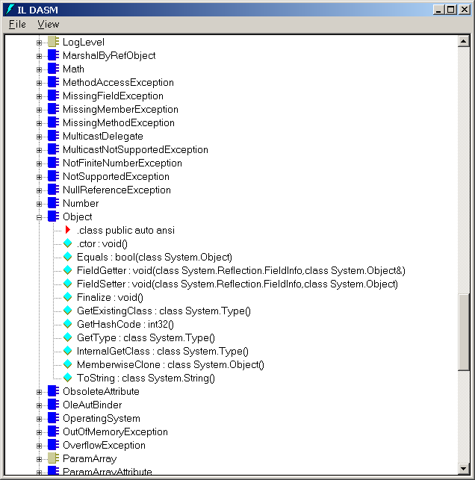
[Figure 3]
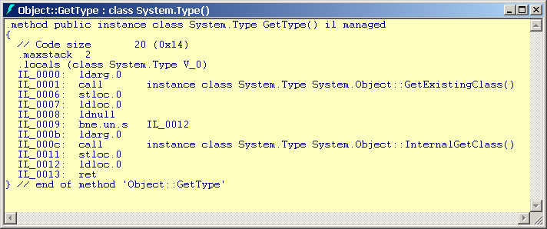
I am constantly using this tool in order to fully understand how NGWS works. Note that the compiler emits types, fields, methods, properties, and event names into the metadata. However, the compiler only emits names given to values, local variables, and parameters in to a module’s PDB file for use when debugging. Since this debug information is not emitted into a module’s metadata, it is much harder for someone to reverse engineer IL code into source code.
Finally, metadata is the technology that enables remote method calls. To make a remote method call, the runtime must allocate a block of memory and lay the method’s parameter data into this block of memory. This process is called serialization and the runtime uses the metadata to know how large a memory block to allocate and how to marshal the parameter data into the block. The block of data is then sent over a stream to the remote machine. Once on the remote machine, the block is deserialized. Again, the metadata provides the template for the memory block. Then the method is called and the method’s return value is remoted back to the originating machine.

Application Deployment
Over the years, the packaging and deployment of Windows applications has gotten quite complex. Applications typically require several different files (EXEs, DLLs, and data files) to run and everyone is familiar with the problem when installing a new application breaks some other application because of some incompatibility between shared files. In addition, many applications – especially COM applications – require several registry settings to help the system locate these files. These application deployment and administration hassles are one of the pet peeves of Windows’ customers and it is a problem that Microsoft is addressing very seriously.
Key to the application deployment and versioning story in NGWS is the introduction of assemblies. As noted earlier, assemblies are collections of behavior designed to work together, built as a single or as multiple files. Depending on the application model you use (e.g., web server application or desktop application), the specifics of deployment may vary somewhat. But, in general, deploying an application need not mean any more than copying a collection of one or more assemblies, one containing your application entry point, to a specific directory that becomes your ‘application directory.’ There is no need to register components because a) every assembly is self-describing; b) every reference to a type is scoped by an assembly reference (as contrasted with COM where all references to types are effectively machine-wide); c) NGWS uses a set of well-defined heuristics to locate referenced assemblies. Let’s take a more detailed look here at assembly identity and assembly references and how they contribute to the versioning story.
An assembly's identity attributes consist of:
- A textual simple name. The resolution heuristics used by the runtime expect that, for persisted assemblies, this name is the same as the name of the file in which the assembly manifest is deployed (excluding file extension). It is carried in metadata so that caching mechanisms may rename the file and still carry the original assembly identity.
- A compatibility version number. Each assembly contains a version in the form of incompat.compat.hotfix. A change in the incompat portion of the version number means that the new version is not compatible with prior versions. A change in the compat portion of the version number means that this is intended to be compatible with prior versions that share the same incompat version number. A change in the hotfix portion of the version number means that, yes, you’ve made a change, but the intention is that it should be considered essentially the same bits as the prior version. The NGWS runtime uses this information in making binding decisions.
- A cultural locale. Every assembly is either the “default” locale or localized for a single locale.
A development tool may be able to generate reasonable defaults for all of these elements, but most expose a way for the author to supply this information explicitly.
The simple name (like My401kApp) is not guaranteed to be unique - there is nothing in the tools or in the runtime to prevent name collisions. There is also nothing to prevent a simple-named assembly from being modified in unintended or uncontrolled ways. This approach works well for private assemblies (intended only for use by the application they are deployed with) but for published assemblies (intended to be shared by multiple applications) a stronger notion of identity is required.
The runtime addresses the problem of name uniqueness and code integrity using standard public-key cryptographic techniques. The approach is to use the public-key value as a unique prefix to the simple, developer generated, name. To insure only the holder of the public-private key pair can publish something with this name, the private key is used to generate a digital signature over the file. This signature can later be verified using the public-key value and has the desireable side-effect of sealing the executable file. Any modifications to the executable file after signing will prevent the signature from verifying. An assembly which is digitally signed in this manner is said to have a shared name that is suitable for publishing.
Shared names satisfy the following requirements:
- Shared names guarantee name uniqueness by relying on unique key-pairs
- Shared names prevent others from "taking over your namespace". Because only you have your private key, no one can generate the same identity that you can. The 401k assembly generated with my private key has a different identity than the 401k assembly generated with your private key. This is particularly important when releasing subsequent versions of your assembly.
- Shared names provide a secure notion of identity. If the runtime verification checks pass, you can be guaranteed that the assembly comes from the person you thought it did (assuming his private key wasn't compromised, of course). Note however that shared names in and of themselves only tell you that the publisher had control of the private-key, not who the publisher was. Microsoft’s Authenticode technology provide a compatible means of establishing the publisher’s name if one wants to use this to make trust decisions.
The way shared (or published) names work is that the assembly developer has a public-private key pair; the private key being closely guarded while the public key is published in the manifest. NGWS provides a set of API's that compilers and "post-link" tools can use to generate shared names and manage the key pairs associated with the names.
When the assembly’s manifest is built, it includes references to all the files that make up the assembly. Each file listed in the manifest is hashed and this hash value is stored along with the file’s name in the manifest. Once the file containing the manifest is built, that file’s entire contents is hashed. This hash value is signed with the publisher’s private key and the resulting RSA digital signature is stored in a reserved section of the file (that was not included in the hash). The file is now ready to be distributed.
When the file is installed on a user’s machine, the system verifies the shared name digital signature using the public key. If the signature fails to verify, then the file’s contents has been tampered with and cannot be trusted. Note that the system only detects if the file containing the manifest has been altered at install time. The detection of another file being altered occurs when the assembly is accessed at runtime.
At runtime, when a reference to an assembly is resolved, the file containing the manifest is located. At this time, the referenced assembly’s public key is compared with the public key that the referencing assembly has on record. If these keys don’t match, then a TypeLoadException exception is raised. This also ensures that the referencing assembly was actually authored by the holder of the private key.
Finally, when other files from this assembly are loaded, the system hashes the file and compares the resulting hash value with the hash value on record for the file (saved in the referenced assembly’s manifest). If the values do not match, the file’s contents has been tampered with and cannot be trusted. The one downside to this approach is that the assembly file is hashed at runtime causing a runtime performance hit.
Remember we said earlier that every reference to a type is scoped by an assembly reference and that this information is carried in the metadata with each file. Another way to look at this is that every file carries information (through these references) about the components (assemblies) and their versions that it was built against. An assembly reference is of the form:
- The simple name of the referenced assembly.
- The compatibility version number of the referenced assembly.
- The locale/culture of the referenced assembly.
- If the referenced assembly has a shared name, the reference also carries the public key (actually, to save space, the referencing assembly may hash the public key and persist the hashed form, but that’s purely an optimization) of the referenced assembly.
Note that this is purely a record of the assembly reference at the time the code was compiled. By default at runtime, NGWS will allow a reference to succeed as long as a compatible version is located at runtime – it needn’t be the exact version. Using a configuration files, an administrator can tailor the exact rules governing the version bindings.
Because the identity of a type includes the identity of the assembly in whose context it was loaded, multiple versions of a type Foo may be loaded at one time. In fact, the runtime delivers a range of technologies that enable it to provide application isolation – among a number of other things, this means that a version of a type used by one application does not affect the version of a type used by another. If you are careful in your implementations in the way you access resources, components are side-by-side in NGWS. In fact, so is the runtime itself… but, that’s for another discussion.
Now that you understand the difference between private assemblies (those without shared names) and published assemblies (those with shared names), I’d like to say a little more about deployment. Your application directory may contain all of the assemblies the application needs to run. In that case, the runtime will use exactly what you deployed there because it honors the application directory first. Although this is the only place that the runtime will look for application private assemblies, you don’t have to re-deploy published assemblies if you don’t want to. You may rely on them being already installed on the machine and/or you may supply a configuration file that provides guidance to the runtime on where they might be found – locally, on your intranet, or across the internet. Aha, you say, what about the download scenario? What about security? I’ll address these issues next.

Verification and Security
Security is integral to the design of NGWS. It starts as soon as a class is loaded, in the form of verification checks, extends to controlling code’s access to resources via code access security, provides mechanisms for determining roles and identity information, reaches across context, process, and machine boundaries so that you can be certain that your data are not compromised in remoting scenarios, and soaks deep into the runtime architecture to ensure that application isolation boundaries are honored. These mechanisms work with, and extend, the security mechanisms commonly found within today’s operating systems.
Overall, runtime security spans the following areas.
Type Safety. Type safe programs reference only memory that has been allocated for their use and access objects only through their exposed interfaces. From a security standpoint, the former allows multiple objects to safely share a single address space and the latter guarantees that security checks associated with specific interfaces are not circumvented.
The runtime insures type safety by combining strong typing in the metadata (parameters, members and array elements, return values of methods, static values) with strong typing in the IL (local variables and stack slots). This provides a basis for automatically verifying the type safety of programs written in IL, independent of the language that produced them. By default, all code loaded by the NGWS runtime requires verification before it is allowed to run. It is recognized that not all ‘safe’ code may be verifiable with existing technology. It is possible to bypass verification if one explicitly trusts an application using administratively controlled policies.
Code Identity. There are only two ways for code to become executable: through the class loader, or through interoperability services (more about this later). Both of these are services provided by the runtime and are part of the security perimeter. For example, the class loader maintains information about the source of every implementation that it loads. Therefore, the class loader is able to reliably provide some of the evidence upon which we can base code identity. This can include information such as which Internet zone and/or site the code originated from, its shared name, and publisher identity. Using this information, security policy can control the privileges a specific application or collection of related applications are granted.
Code Access Security. Code Access Security is a mechanism that provides policy-based enforcement over privileges granted to executing assemblies. These privileges can control access to system resources and other code. It is based on the notion of permissions. NGWS provides a fairly broad set of permissions related to common resources and code evidence-based identity. Tools or application developers can extend these by adding new permission types to meet specific needs.
Permissions are logically grouped into permission sets that are granted by the NGWS security system to assemblies. It is these granted permissions that define what code is allowed to do. They are determined based on code evidence. The evidence is used to determine a set of policy code-groups for a given assembly, which is then used by the security system to determine the correct permission set to grant.
In use, permissions are typically demanded by trusted code such as a class that encapsulates access to the local file system. A demand causes the security system to check that the calling assembly(s) have the required permission. A typical application will simply make calls to such trusted resource managing code and will not need to incorporate any security specific code.
Resource Permissions. Resource permissions are associated with information or communications resources within the system. Examples include files, display windows, clipboard, network channels, application private storage (IsolatedStorage), the ability to make calls to unmanaged APIs, and so forth. These can be used to determine if code has rights to access specific resources at either load time or runtime (see declarative security below).
Consider the case of an application that wants to read and write a file in “C:\Temp”. To open a file in this directory, a managed application would use the base class library’s System.IO.File class. This class contains a static method called Open. Internally, the Open method takes the pathname of the file the caller wishes to open and asks the runtime engine if access to the specified pathname is allowed. This is called demanding access. In this case, the Open method demands that the calling code be granted a FileIO permission with read and write access to “C:\Temp\*.*” before it will attempt to open the file.
When a method demands access, the runtime walks up the call stack and checks to see if all assemblies in the call chain have the required permission. If any code in the call chain lacks the required permission, then the demand fails and a security exception is thrown, otherwise the demand succeeds. To complete the file open operation, the File class next needs to call the OS file system APIs. This requires the UnmanagedCode permission, which is typically granted to highly trusted resource managing classes. The system will check that the File class has this permission before allowing the call to unmanaged code. Note that we don’t expect the other, semi-trusted, assemblies in the call chain to have been granted this permission. To allow the UnmanagedCode permission demand to succeed, highly trusted code is allowed to assert its right to use a permission. This causes the permission check stack walk to terminate at the assembly that asserted the permission.
Identity Permissions. Identity permissions are based on evidence associated with a given assembly (Site, Zone, Shared Name, and Publisher). They allow one to control access to class methods based on this information. They operate in the same manner as resource permissions. Code demands calling code have a given identity attribute. If the caller(s) have the demanded identity attribute the call succeeds, otherwise a security exception is thrown.
Declarative Security. Declarative security is a very powerful mechanism that allows a developer to insert code access security checks into their code by annotating classes, fields, or methods. The declarations are encoded in the assembly metadata and enforced by the NGWS security system. Using such declarations one can request checks be performed at either load time or run-time.
Load time checks are more efficient in that they are only checked once during execution, as opposed to on each call to a method, but also more limited. They only check the permissions (resource or identity) of the immediate caller. The developer needs to carefully assess whether this is adequate for a given situation. Typically, load time checks are used to limit access to specific classes. For example, one can use a load time identity check to insure only code from specific publisher or with a given shared name public-key can be the immediate caller to a class. One can also use these checks to limit that ability to sub-class or override virtual methods.
Declarative runtime checks are a simple means to indicate permission demands and asserts for a given type. Demands cause a full stack walk to check the permissions of all code in the call chain as discussed previously. They are appropriate when the desired action and permission attributes are static. That is, if one always demands read permission to “C:\Temp” it is easy to express this declaratively. But if one needs to dynamically create the check to account for different access modes and directory/file names then imperative checks (described next) are needed.
Imperative Security. Imperative security checks are implemented as code within a method by the application developer. They are enforced in exactly the same manner as declarative run time checks. The benefit in using them is that one can support dynamic determination of specific permissions required in a given execution context. This is typically important for permissions such as FileIO, IsolatedStorage, UI, and so forth that support multiple access modes and sub-setting of the resources being accessed.
Policy. To enable effective use of code access security requires a policy-based system. Policy allows one to make specific statements about what code should be allowed to do based on its point-of-origin and other identifying information. Using this policy, appropriate privileges are automatically granted to code without any required user interaction. NGWS ships with a default policy that reflects the different levels of trust users typically place on code on their local system, code from known trusted servers, and code from untrusted Internet sites. The user may refine this policy as desired.
Role-based Security. It is fairly common for developers to make authorization decisions based on the identity and/or role(s) associated with the execution context. One often sees this in financial or business systems as a means of policy enforcement. For example, one may impose limits on the value of a transaction depending on the role of the user making the request. Clerks may be able to process transactions up to some set value, supervisors to some higher limit, and VPs yet a higher limit. NGWS provides services to allow applications to easily incorporate such logic in a way that is platform independent and scalable to the Internet.
The NGWS mechanisms are built around the notion of identities and principals. Identities encapsulate entity naming that the application understands. This can map to underlying OS notions of accounts, but can also be application defined. The corresponding principal encapsulates the identity along with corresponding role information. Again, this could map to an OS notion such as groups but need not.
In operation, a trusted authentication provider will typically compute the principal information based on credentials associated with a given request (HTTP Put, remote procedure call, …) The principal is then attached to the execution context making it available to application code to check the role or identity information prior to taking a given action.
Remoting Security. NGWS provides support for remote object invocation that can span AppDomains, processes, or machines. When crossing machine boundaries security issues such as authentication, authorization, confidentiality, and integrity become critically important. NGWS will provide support for these mechanisms that is compatible with existing network protocols and integrates tightly into the remoting infrastructure. This will make it simple for applications to incorporate these features.
Authentication mechanisms will be suitable for identification of interact users as well as applications or business entities. A key-based identity infrastructure will be provided for managing such identities and integrating with key-based authentication protocols. Confidentiality and integrity services will leverage cryptographic techniques. It will be possible to use point-to-point mechanisms such as SSL and IPSEC. But, we will also support application layer encryption, integrity, and digital signature technologies at the messaging level.
Cryptography. NGWS provides a set of cryptographic objects supporting well-known algorithms and common uses (hashing, encryption, digital signatures). These are designed in a manner that facilities composing these basic capabilities into more complex operations such as signing and encrypting a document. These objects are used by NGWS to support internal services, but are also available to application developers who need cryptographic support.

Putting It All Together
So now that you’ve been introduced to the key concepts of the NGWS runtime, let’s actually deploy and run our code. Let’s say that we build an application that’s a single assembly containing multiple files as depicted below:
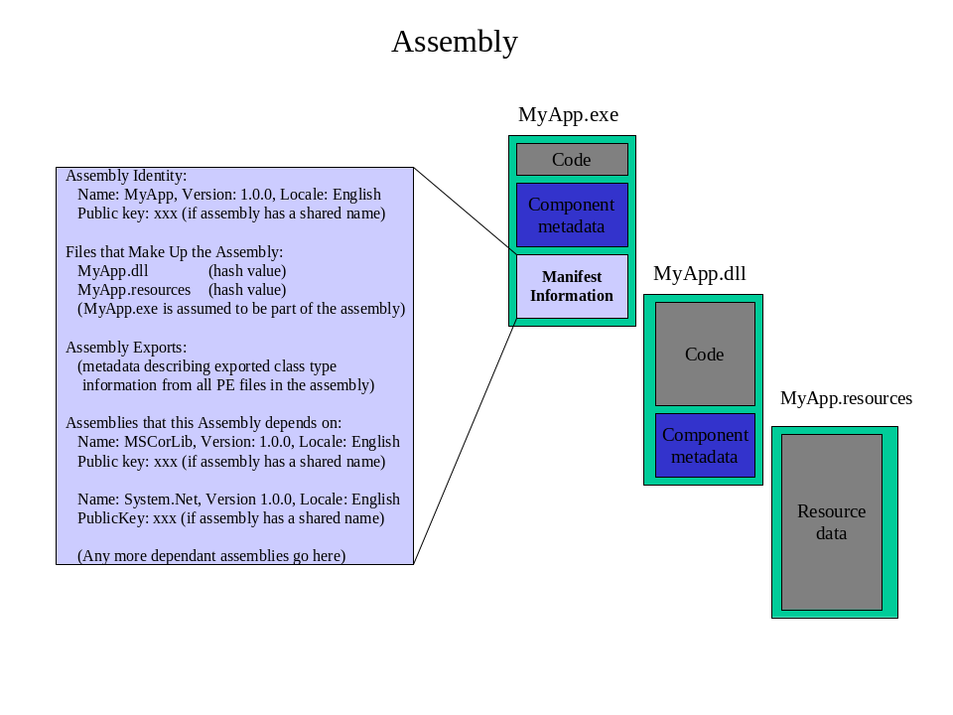
The assembly manifest is embedded in MyApp.exe. It shows the 3 files that make up the assembly, which types are defined in the assembly’s files (MyApp.exe and MyApp.dll), and what other assemblies the MyApp assembly requires to execute. In this example, MyApp requires the NGWS base class library assembly (version 1.0, English).
Let’s say that your assembly has been copied to a user’s machine and resides on their local hard disk. One of the assemblies that your application references has been installed into the global assembly cache on that user’s machine (described in a little more detail later), so that any application can just find it there. The other assembly is not deployed with your application but rather is deployed on a server on your company’s intranet.
The user double-clicks on your EXE. Since the PE file is a NGWS file, the runtime initializes and establishes a “domain” for the application. The assembly is then loaded into the domain, essentially just reading in the assembly manifest (note that the runtime does not do eager validation of the manifest – such as verifying that all of its files are present and/or that referenced assemblies are available). Next, the entry point for the application is loaded, verified, jitted, and the code begins to execute.
As the code executes, it may make references to other types. Such references will be in one of three forms:
- A reference to a type in the same file. In this case, the reference is early bound and the type is loaded out of the file directly.
- A reference to a type in another file in the same assembly. In this case, the runtime makes sure that the file being referenced is, in fact, in the file list in the current assembly’s manifest and then looks in the application’s directory for the file to load.
- A reference to a type in a dependent assembly. In this case, the runtime resolves the reference using the heuristics described below.
- The runtime passes the assembly reference to the assembly resolver. The assembly resolver will pick up from the application’s directory any configuration information that might affect the binding rules, such as version binding, and the result may be a modified form of the persisted assembly reference.
- If the reference does not have a shared name (that is, does not include a public key and is thus considered a private assembly):
  - The assembly resolver looks in the specified application directory for a file with the same name as the assembly, and, if found, makes sure that all of the attributes passed with the reference match those in the located manifest.
  - If successful, the assembly resolver returns a pointer to the assembly manifest at its persisted file location.
  - If not successful, a TypeLoadException exception is raised.
- If the reference has a shared name (that is, has been published with a public key, which is our example):
  - The assembly resolver looks in the specified application directory for a file with the same name as the assembly, and, if found, makes sure that all of the attributes passed with the reference match those in the located manifest, including using the public key to check the manifest file signature. The reason that the assembly resolver looks first in the application directory is to give the application an opportunity to deploy a preferred version of the assembly, even if there might be another version already loaded in the global assembly cache.
  - If successful, the assembly resolver returns a pointer to the assembly manifest at its persisted file location.
  - If not found in the application directory, the assembly resolver looks in its global cache to see if an appropriate version of the assembly has already been installed. If so, the assembly resolver simply returns a pointer to the assembly manifest in the global assembly cache.
  - If not found in the specified application directory or in the global assembly cache, the assembly resolver uses a search path provided in the configuration information for the application. If the assembly was located off the machine, it is downloaded into a transient assembly cache.
  - If not found in any of these locations, a TypeLoadException exception is raised.
The assembly cache is a directory normally residing in the C:\WinNT\Assembly directory. When assemblies are installed on the machine, they can get merged into the assembly cache. The assembly cache consists of two logically separate caches: the global assembly cache and the transient assembly cache.
When using MSI files to distribute an assembly, the MSI file can be authored so that assemblies are automatically added to the global assembly cache. When assemblies are downloaded using Internet Explorer, the assembly is installed in the transient assembly cache. The reason for keeping these assemblies logically separate is to prevent a downloaded module from adversely impacting an installed application.
It should also be noted that the assembly cache could hold multiple versions of an assembly. For example, the assembly cache could contain version 1 and version 2 of MyAssem.dll. If an application was built and tested using version 1 of MyAssem.dll then the runtime will load version 1 of MyAssem.dll for that application even though a later version of the assembly exists in the cache. An administrator can change this version policy but doing so is not recommended because the strict version policy resolves the classic “DLL Hell” problems. The application should behave as it always has because the code that it is executing is the same code that it was built and tested with. This also means that version 2 of MyAssem.dll doesn’t have to maintain backward compatibility with version 1.

Interoperability with Unmanaged Code
The managed code environment offered by the runtime provides a ton of features to the developer making software development such a pleasure. However, the operating system on which the runtime executes also offers a number of features and it would be a terrible misfortune if managed applications were restricted from using the native operating system’s services or other unmanaged code.
To this end, the runtime offers a System.Runtime.InteropServices namespace. This namespace contains a set of types that allow managed applications to access unmanaged code. Specifically, there are three supported interop scenarios:
- Managed code calling unmanaged DLL functions. To call an unmanaged DLL function, you just need to tell the runtime the name of the function you wish to call (e.g. MessageBoxA), the name of the DLL containing the function (e.g. User32.dll), and how to marshal the function’s parameters (e.g. which parameters are input, output or input/output parameters).
- Managed code instantiating and calling interface methods of classic COM servers. To work with a COM server, a NGWS wrapper must be created so that NGWS clients think that they are calling NGWS code; the underlying details are handled seamlessly by the runtime. The TlbImp.exe utility parses a COM type library and produces a managed DLL whose metadata describes the methods that wrap the COM server’s interface methods. A managed application can now create instances of the object and use it as though it were a native managed type. For each COM server, the runtime generates a runtime callable wrapper. This wrapper acts as a proxy between the managed and unmanaged code handling all administrative tasks such as marshalling, AddRef, Release, and so on.
- Unmanaged code instantiating and calling methods on NGWS servers. In order for an unmanaged application to instantiate and use a managed NGWS server, the NGWS object must be added to the system’s registry (since that’s how COM expects to locate COM servers). The register assembly utility, RegAsm.exe, generates a GUID for the NGWS server and updates the registry. If the unmanaged code desires a type library, one can be generated using the TlbExp.exe utility. An unmanaged application can now create instances of the object and use it as though it were a COM server. For each type of managed NGWS server, the runtime generates a COM callable wrapper. This wrapper acts as a proxy between the unmanaged and managed code handling all administrative tasks such as marshalling, AddRef, Release, and so on.
Due to the runtime’s interoperability features, developers do not have to give up anything in order to gain the benefits offered by the runtime. In addition, the runtime makes working with COM servers even easier than it would be from unmanaged C/C++ code. Of course, transitioning between managed and unmanaged code is has its performance issues. When possible, you should do whatever you can to reduce these transitions. This may mean porting your COM server to NGWS. At least, the interoperability features allow you to make this decision on your own time when you’re ready.

Just the Beginning
This chapter introduces the NGWS runtime and briefly mentions some of the technologies that it offers. However, this chapter does not describe the services Microsoft is delivering via its class libraries. In particular, Microsoft is creating a new database access model, called ADO+, that exposes database functionality via NGWS types contained in the System.Data namespace. Microsoft is also creating a class library, called WinForms, for creating stand-alone applications with rich user-interfaces. You can find these types in the System.WinForms namespace.
Finally, Microsoft is providing a new architecture for producing web applications called ASP+. This architecture includes a class library of types that render complex visuals as HTML. The architecture also manages all client/server state information making rapid web application development a breeze. You can learn more about these types by examining the System.Web namespace.
It should be clear from this chapter that Microsoft is tired of placing band-aids on Windows. It should also be clear that Microsoft recognizes the direction of our computing lifestyles, is adjusting its thinking, and is breaking with tradition to bring a new, modern platform to developers and end-users.
End-users will not directly appreciate the runtime and its capabilities but end-users will certainly notice the quality and features of applications that utilize the runtime. In addition, end-users and your company’s bottom line will certainly appreciate how the runtime allows applications to be developed and deployed more rapidly and with less administration than Windows has ever allowed in the past.

Chapter 2
NGWS Platform-Specific Programming Topics
The purpose of this book is to explain the NGWS runtime and the facilities it offers. With this book, I am not attempting to teach programming and object-oriented concepts. However, there are some common programming topics that are specific to the NGWS platform. These topics are so useful that all NGWS developers must be aware of them. These topics are addressed in this chapter and will be used through the remaining chapter of the book. Note that this chapter offers a grab bag of topics arranged in a loose order; the sections do not have to be read sequentially.
You should also be aware that I have decided to use C# as my language of choice throughout this entire book. This is because C# is Microsoft’s language designed specifically for developing managed code. While the sample code shown in this chapter is in C# and while the explanations are geared toward coding with C#, the concepts discussed are concepts exposed by the runtime and therefore apply to any language that targets NGWS.
One final note before we start: the purpose of this chapter is to introduce to you the various topics, give some idea of how they’re implemented, and also to explain when each is best used. This chapter does not fully describe each topic and all the nuances that surround it. For complete details on any topic presented, please refer to the runtime or language documentation. Now, with all the disclaimers out of the way, let’s begin…

Let’s Not Repeat History
For Win32 SDK programmers, access to most of the operating system platform’s features is exposed via a set of stand-alone functions exported from dynamic-link libraries (DLLs). These stand-alone functions are very easy to call from non-object oriented languages like C. However, it is quite daunting for new Windows developers to face literally thousands of independent functions that, on the surface, seem to have little, if any, relation to one another. Making things even harder is the fact that many functions start with the word Get (i.e. GetCurrentProcess and GetStockObject). In addition, the Win32 API has evolved over the years and Microsoft has added new functions having similar semantics but offering slightly different features over the earlier functions. You can usually identify the newer functions because their names are similar to the original function’s name (i.e. CreateWindow/CreateWindowEx, CreateTypeLib/CreateTypeLib2, and one of my personal favorites: CreatePen/CreatePenIndirect/ExtCreatePen).
All of these issues and more have given developers the impression that developing for Windows is difficult. With NGWS, Microsoft is finally addressing developers’ cries for help and is creating a whole new platform that is accessed entirely using an object-oriented paradigm. Platform services are now divided into namespaces (such as System.Collections, System.Data, System.IO, System.Security, System.Web, and so on) and each namespace contains a set of related class types that allow access to the platform’s services.
Since class methods may be overloaded, methods that differ just slightly in their behavior are given identical names and differ only by their prototypes. For example, a class might offer three different versions of a CreatePen method. All methods do the same thing: create a pen. However, each method takes a different set of parameters and has slightly different behavior. In the future, should Microsoft need to create a fourth CreatePen method, the new method would fit seamlessly into the class as a first class citizen.
Since all platform services are offered via this object-oriented paradigm, software developers should have some understanding of object-oriented programming. The object-oriented paradigm allows other features as well. Specifically, it is now very easy to create specialized versions of the base class library’s types using inheritance and polymorphism. Again, if you’re not familiar with these concepts, I strongly suggest you find a book that teaches these concepts, as they are now critical to working with the NGWS platform.

All Object Types are Derived from System.Object
In NGWS, every object is ultimately derived from the System.Object type. This means that the following two type definitions (shown using C#) are identical:
class Jeff { class Jeff : System.Object {
. .
. .
. .
} }
Since all object types are ultimately derived from System.Object, you are guaranteed that every object of every type has a minimum set of capabilities. Specifically, the System.Object class offers the following public methods:
Method | Description
Equals | This method compares two object references and returns true if both references refer to the same, exact object. For unboxed value types (discussed later), this method returns true if two different objects are of the same type and contain the same, exact information.  This method is commonly overridden to return if two objects have identical values instead of referring to the same object.
GetHashCode | Gets a hash code for this object. By default, this can be used to uniquely identify an object. However, a type should override this method if its objects are to be used as a key in a hashtable. The method should provide a good distribution for its objects.
GetType | Returns the Type-derived object identifying the type of this object. The returned Type object can be used with the Reflection classes to obtain metadata information about the type.
ToString | By default, this method returns the full name of the type. However, it is common to override this method so that it returns a String object containing a string representation of the object’s state.
The runtime requires that all object instances be created using the new operator (which calls the newobj IL instruction). The line below shows how to create an instance of the Jeff type (declared above):
Jeff j = new Jeff("ConstructorParam1");
Here is what the new operator does:
- It creates the object by allocating the number of bytes required for the specified type from the managed heap.
- It initializes the object’s overhead members. Every object has some additional bytes that the runtime uses to manage the object. For example, the object’s virtual table pointer and a reference to a sync block (described in the Threads chapter).
- The class type’s constructor is called passing it any parameters (the string "ConstructorParam1", in the example above) specified in the call to new. Note that most languages will compile constructors so that they call the base type’s constructor; however, this is not required by the VOS.
After new has performed all of the operations above, it returns a reference to the newly created object. In the example code above, this reference is saved in the variable j, which is of type Jeff.
By the way, the new operator has no counterpart. That is, there is no way to explicitly free or destroy an object. The runtime offers a garbage-collected environment (described in Chapter 3) that automatically detects when objects are no longer being used or accessed and frees the objects automatically.

Casting Between Data Types
When programming, it is quite common to cast an object from one data type to another. In this section we look at the rules governing how objects are cast between data types. To start, let’s look at the following line:
System.Object o = new Jeff("ConstructorParam1");
This line compiles and executes correctly because there is an implied cast. The new operator returns a reference to a Jeff type but o is a reference to a System.Object type. Since all types (including the Jeff type) can be cast to System.Object, the implied cast is successful.
However, if I now execute the following line, we get a compiler error since the compiler does not provide an implicit cast from a base type to a derived type.
Jeff j = o;
To get the line above to compile, we must insert an explicit cast, as follows:
Jeff j = (Jeff) o;
Now, the code compiles and executes successfully.
Let’s look at another example:
System.Object o = new System.Object();
Jeff j = (Jeff) o;
On the first line, we have created an object of type System.Object. On the second line, we are attempting to convert a reference of type System.Object to a reference of type Jeff. Both lines of code compile just fine. However, when executed, the second line generates an InvalidCastException exception, which if uncaught, forces the application to terminate.
When the second line of code above executes, the runtime verifies that the object actually referred to by o is in fact an object of type Jeff (or any type derived from type Jeff). If so, the runtime allows the cast. However, if the object referenced by o has no relationship to Jeff or is a base class of Jeff, then the runtime prevents the unsafe cast and raises the InvalidCastException exception.
C# offers another way to perform a cast using the as operator:
Jeff j = new Jeff(); // Create a new Jeff object
System.Object o = j as System.Object; // Casts j to an object
// o now refers to the Jeff object
The as operator attempts to cast an object to the specified type. However, unlike normal casting, the as operator will never throw an exception. Instead, if the object’s type cannot be cast successfully, then the result is null. When the ill-cast reference is used, a NullReferenceException exception will be thrown. The following code demonstrates:
System.Object o = new System.Object(); // Creates a new Object object
Jeff j = o as Jeff; // Casts o to a Jeff
// The cast above fails: no exception is raised but j is set to null
j.ToString(); // Accessing j generates a NullReferenceException
In addition to the as operator, C# also offers an is operator. The is operator checks whether an object instance is compatible with a given type and the result of the evaluation is either True or False. The is operator will never raise an exception. The code below demonstrates:
System.Object o = new System.Object();
System.Boolean b1 = (o is System.Object); // b1 is True
System.Boolean b2 = (o is Jeff); // b2 is False
Note, if the object reference is null, the is operator always returns False since there is no object available to check its type.
To make sure you understand everything just presented, take the following quiz. Assume that the following two class definitions exist.
class B {
int x;
}
class D : B {
int x;
}
Now, examine the lines of code below. For each line, decide whether the line would compile and execute successfully (ES), cause a compiler error (CE), or cause a runtime error (RE).
Statement | ES | CE | RE
System.Object o1 = new System.Object(); | X
System.Object o2 = new B(); | X
System.Object o3 = new D(); | X
System.Object o4 = o3; | X
B b1 = new B(); | X
B b2 = new D(); | X
D d1 = new D(); | X
B b3 = new System.Object(); |  | X
D d3 = new System.Object(); |  | X
B b3 = d1; | X
D d2 = b2; |  | X
D d4 = (D) d1; | X
D d5 = (D) b2; | X
D d6 = (D) b1; |  |  | X
B b4 = (B) o1; |  |  | X
B b5 = (D) b2; | X

(Assemblies and) Namespaces
A collection of types can be grouped together into an assembly (a set of 1 or more files) and deployed. Within an assembly, you can have namespaces. To the application developer, namespaces look like logical groupings of related types. For example, the base class library assembly contains many namespaces. The System namespace includes core low-level types such as the Object base type, Byte, Int32, Exception, Math, and Delegate, while the System.Collections namespace includes such types as ArrayList, BitArray, Queue, and Stack.
To the compiler, a namespace is simply an easy way of making a type’s name longer and more unique by preceding the name with some symbols separated by dots. So, to the compiler, the Object type in the System namespace really just identifies a type called System.Object. Similarly, the Queue type in the System.Collections namespace simply identifies a type called System.Collections.Queue.
The runtime engine doesn’t know anything about namespaces at all, when you access a type, the runtime just needs to know the full name of the type and which assembly contains the definition of the type so that the runtime can load the proper assembly, find the type and manipulate it.
Programmers usually want the tersest way of expressing their algorithms and it is extremely inconvenient to refer to every class type using its fully qualified name. For this reason, many programming languages offer a statement that instructs the compiler to “try” pre-pending different prefixes to a type name until a match is made. When writing in C#, I usually place the following line at the top of my source code modules:
using System;
When I refer to a type in my code, the compiler needs to ensure that the type is defined and that my code accesses the type in the correct way. If the compiler can’t find a type with the specified name, it tries pre-pending “System.” to the type name and checks if the generated name matches an existing type. The line of code above, allows me to use Object in my code, and the compiler will automatically expand the name to System.Object. I’m sure you can easily imagine how much typing this saves.
When checking for a type’s definition, the compiler must know which assembly contains the type so that the assembly information and the type information can be emitted into the resulting file. To get the assembly information, you must pass the assembly that defines any referenced types to the compiler.
As you might imagine, there are some potential problems with this scheme. For programming convenience, you should avoid creating types that have conflicting names. However, in some cases, it is simply not possible. NGWS encourages the reuse of components. Your application may take advantage of a component created by Microsoft and another component created by Wintellect. These two companies’ components may both offer a type called FooBar -- Microsoft’s FooBar does one thing and Wintellect’s FooBar does something entirely different. In this scenario, you had no control over the naming of the class types. To reference Microsoft’s FooBar, you’d use Microsoft.FooBar and to reference Wintellect’s FooBar, you use Wintellect.FooBar.
In the code below, the reference to FooBar is ambiguous. It might be nice if the compiler reported an error here but the C# compiler actually just picks one of the possible FooBar types; you won’t discover a problem until runtime:
using Microsoft;
using Wintellect;
class MyApp {
method void Hi() {
FooBar f = new FooBar(); // Ambiguous, compiler picks
}
}
To remove the ambiguity, you must explicitly tell the compiler which FooBar you want to create:
using Microsoft;
using Wintellect;
class MyApp {
method void Hi() {
Wintellect.FooBar f = new Wintellect.FooBar(); // Not ambiguous
}
}
There is another form of the using statement that allows you to create an alias for a single type. This is handy if you have just a few types that you use from a namespace and don’t want to pollute the global namespace with all of a namespace’s types. The code below demonstrates another way to solve the ambiguity problem shown above:
// Define WintellectFooBar symbol as an alias to Wintellect.FooBar
using WintellectFooBar = Wintellect.FooBar;
class MyApp {
method void Hi() {
WintellectFooBar f = new WintellectFooBar(); // No error now
}
}
These methods of disambiguating a type are useful but there are scenarios where this is still not good enough. Imagine that the Australian Boomerang Company (ABC) and the Alaskan Boat Corporation (ABC) are each creating a type, called BuyProduct, which they intend to ship in their respective assemblies. It is likely that both companies would create a namespace called ABC that contains a type called BuyProduct. Anyone who tries to develop an application that needs to buy both boomerangs and boats would be in for some trouble unless your programming language gives you a way to programmatically distinguish between the assemblies; not just between namespaces.
Unfortunately, C#’s using statement only supports namespaces and does not offer any way to specify an assembly. However, in the real world, this problem does not come up very often and is rarely an issue. If you are designing component types that you expect 3rd parties to use, it is highly recommended that you define these types in a namespace so that compilers can easily disambiguate types. In fact, you should use your full company name (not an acronym) to be your top-level namespace name in order to reduce the likelihood of conflict. You can see that Microsoft uses a namespace of “Microsoft” for Microsoft-specific types.
Creating a namespace is simply a matter of writing a namespace declaration into your code as follows:
namespace CompanyName { // CompanyName
class A { // CompanyName.A
class B { ... } // CompanyName.A.B
}
namespace X { // CompanyName.X
class C { ... } // CompanyName.X.C
}
}
Note that namespaces are implicitly public and you cannot change this by including any access modifiers. However, you can define types within a namespace that are internal (can’t be used outside the assembly) or public (can be accessed by any assembly). Namespaces denote logical containment only; accessibility or packaging is accomplished by placing the namespace into an assembly.

Primitive Types
There are certain data types that are so commonly used that many compilers allow your code to manipulate them using simplified syntax. For example, you could allocate an integer using the following syntax:
int a = new int(5);
But, I’m sure you’ll all agree that declaring and initializing an integer using the syntax above is rather cumbersome. Fortunately, many compilers (including C#) allow you to use syntax similar to the following instead:
int a = 5;
This certainly makes the code more readable. And, of course the IL generated when using either syntax is identical. Any data types directly supported by the compiler are called primitive types. Primitive types map directly to types existing in the base class library. For example, in C# an int maps directly to the System.Int32 type. Because of this, the two lines of code below are identical to the two lines of code shown above:
System.Int32 a = new System.Int32(5);
System.Int32 a = 5;
The table below shows the base class library types that have corresponding primitives in C# (other languages will offer similar primitive types):

C# Primitive Type | BCL Type | Description
sbyte | System.SByte | Signed 8-bit value
byte | System.Byte | Unsinged 8-bit value
short | System.Int16 | Signed 16-bit value
ushort | System.UInt16 | Unsigned 16-bit value
int | System.Int32 | Signed 32-bit value
uint | System.UInt32 | Unsigned 32-bit value
long | System.Int64 | Signed 64-bit value
ulong | System.UInt64 | Unsigned 64-bit value
char | System.Char | 16-bit Unicode character
float | System.Single | IEEE 32-bit float
double | System.Double | IEEE 64-bit float
bool | System.Boolean | A True/False value
decimal | System.Decimal | 96-bit signed integer times 10⁰ thru 10²⁸ (common for financial calculations where rounding errors can’t be tolerated)
object | System.Object | Base of all types
string | System.String | String type

Values Types and Reference Types
When an object is allocated from the managed heap, the new operator returns the memory address of the object. We usually store this address in a variable. This type of variable is called a reference type variable because the variable does not contain the object’s bits; instead, the variable refers to the object’s bits.
There are some performance considerations to consider when working with reference types. First, the memory must be allocated from the managed heap, which could force a garbage collection to occur. Second, reference types are always accessed via their pointers. So, every time your code references any member of an object on the heap, code must be generated and executed to dereference the pointer in order to perform the desired action. This hurts performance in both size and speed.
In addition to reference types, the virtual object system supports “lightweight” types called value types. Value type objects cannot be allocated on the garbage-collected heap and the variable representing the object does not contain a pointer to an object; the variable contains the object itself. Since the variable contains the object, a pointer does not have to be dereferenced in order to manipulate the object. This, of course, improves performance.
The code below demonstrates how reference types and value types differ:
// Reference Type (because of ‘class’)
class RectRef { public int x, y, cx, cy; }
// Value type (because of ‘struct’)
struct RectVal { public int x, y, cx, cy; }
static void SomeMethod {
RectRef rr1 = new RectRef(); // Allocated in heap
RectVal rv1; // Allocated on stack (new optional)
rr1.x = 10; // Pointer dereference
rv1.x = 10; // Changed on stack
RectVal rv2 = rv1; // Allocate on stack & copy members
RectRef rr2 = rr1; // Copies pointer
rv1.x = 20; // Changes value in heap
rr1.x = 20; // Changes rr1, not rr2
}
In the code above, the Rectangle type is declared using struct instead of the more common class. In C#, a type declared using struct is a value type while types declared using class are reference types.
Other languages may have different syntax for describing value types versus reference types. For example, C++ uses the __value modifier.
Recall the following line of code previously discussed in the Primitive Types section:
System.Int32 a = new System.Int32(5);
When this statement is compiled, the compiler detects hat the System.Int32 type is a value type and optimizes the resulting IL code so that this “object” is not allocated from the heap; instead, this object is placed on the thread’s stack in the local variable (a).
When possible, you should use value types instead of reference types because your application’s performance will be better. In particular, you should declare a type as a value type if all of the following are true:
- the type acts like a primitive type
- the type doesn’t need to inherit from any other type
- the type will not have any other types derived from it
- objects of the type are not frequently passed as method arguments since this would cause frequent memory copy operations hurting performance. The next section on boxing and unboxing will explain this in more detail.
The main advantage of value types is that they are not allocated in the managed heap. Of course, value types have several limitations over reference types. Here are some of the ways in which value types and reference types differ:
- Value type objects have two representations: an unboxed form and a boxed form (discussed in the next section). Reference types are always in a boxed form.
- Value types are implicitly derived from System.ValueType.
- Since you cannot declare a new value type or a new reference type using a value type as a base class, value types should not have virtual functions, cannot be abstract, and are implicitly sealed.
- Reference type variables contain the memory address of objects in the heap. By default, when a reference type variable is created, it is initialized to null indicating that the reference type variable doesn’t currently point to a valid object. Attempting to use a null reference type variable causes a NullReferenceException exception. By contrast, value type variables always contain a value of the underlying type. By default, all members of the value type are initialized to zero. It is not possible to generate a NullReferenceException exception when accessing a value type.
- When you assign a value type variable to another value type variable, a copy of the value is made. When you assign a reference type variable to another reference type variable, only the memory address is copied.
- Because of the previous point, two or more reference type variables may refer to a single object in the heap. This allows operations on one variable to affect the object referenced by the other variable. On the other hand, value type variables each have their own copy of the “object’s” data and it is not possible for operations on one value type variable to affect another.
- Under very rare circumstances, it is possible to create an instance of a value type in such a way that the runtime can’t call the type’s default constructor. However, the runtime does ensure that all members are initialized to 0 or null. For this reason, it is recommended that you not define a parameterless constructor on a value type. In fact, the C# compiler (and others) considers this an error and won’t compile the code. This rarely-occurring problem never occurs on reference types. There are no restrictions on parameterized constructors for both value types and reference types.
- Since unboxed value types are not allocated on the heap, the storage allocated for them is freed as soon as the method that defines an instance of the type is no longer active. This also means that unboxed value type objects cannot receive a notification when their memory is reclaimed. However, a boxed value type will have its Finalize method called when it is garbage collected. See Chapter 3 for more information about the heap, garbage collection, and the Finalize method. You are strongly discouraged from implementing a value type with a Finalize method. In fact, C# considers this an error and will not compile the source code.

Boxing and Unboxing
There are many situations where it is convenient to treat a value type as a reference type. For example, let’s say that you wanted to create an ArrayList object (a type defined in the System.Collections namespace) to hold a set of Points. The code might look like this:
// Declare a value type
struct Point {
public int x, y;
}
static void Main() {
ArrayList a = new ArrayList();
for (int i = 0; i < 10; i++) {
Point p; // Allocate a Point (not in the heap)
p.x = p.y = i; // Initialize the members in the value type
a.Add(p); // Box the value type and add the
// reference to the array
}
.
.
.
}
With each iteration of the loop above, a Point value type is initialized. Then, the Point is stored in the ArrayList. But, let’s think about this for a moment. What is actually being stored in the ArrayList, the Point structure, the address of the Point structure, or something else entirely? To get the answer, we must look up the ArrayList’s Add method and see what type its parameter is defined as. In this case, we see that the Add method is prototyped as follows:
public virtual void Add(Object value)
From this, we plainly see that Add takes an Object as a parameter. Object always identifies a reference type. But, in the code above, I’m passing p: a Point value type. For the code above to work, the Point value type must be converted into a true heap-managed object and a reference to this object must be obtained.
Converting a value type to a reference type is called boxing. Internally, here’s what happens when a value type is boxed:
- Memory is allocated from the heap. The amount of memory allocated is the size required by the value type plus any additional overhead to consider this value a true object. The additional overhead includes a pointer to a virtual method table and a pointer to a sync block.
- The value type’s bits are copied to the newly allocated heap memory.
- The address of the object is returned. This address is now a reference type.
Some language compilers, like C#, automatically produce the IL code necessary to box the value type but it is important that you understand what’s going on under the covers so that you are aware of code size and performance issues.
When the Add method is called, memory is allocated in the heap for a “Point object”. The members currently residing in the Point value type (p) are copied into the newly allocated Point object. The address of the Point object (a reference type) is returned and is then passed to the Add method. The Point object will remain in the heap until it is garbage collected. The Point value type variable (p) can be reused or freed since the ArrayList never knows anything about it.
Boxing enables a unified view of the type system wherein a value of any type can ultimately be treated as an object.
The opposite of boxing is, of course, unboxing. Unboxing retrieves a reference to the value type (data fields) contained within an object. Internally, here’s what happens when a reference type is unboxed:
- The Runtime first ensures that the reference type variable is not null and that it refers to an object that is a boxed value of the desired value type. If either test fails, then an InvalidCastException exception is generated.
- If the types do match, then a pointer to the value type contained inside the object is returned. The value type that this pointer refers to does not include the usual overhead associated with a true object: a pointer to a virtual method table and a sync block.
Note that boxing always creates a new object and copies the unboxed value’s bits to the object. On the other hand, unboxing simply returns a pointer to the data within a boxed object: no memory copy occurs. However, it is common that your code will cause the data pointed to by the unboxed reference to be copied anyway.
The code below demonstrates boxing and unboxing:
public static void Main() {
Int32 v = 5; // Create an unboxed value type variable
Object o = v; // o refers to a boxed version of v
v = 123; // Changes the unboxed value to 123
Console.WriteLine(v + ", " + (Int32) o); // Displays "123, 5"
}
In this code, can you guess how many boxing operations occur? You might be surprised to discover that the answer is 3! Let’s analyze the code carefully to really understand what’s going on.
First, an Int32 unboxed value type (v) is created and initialized to 5. Then, an Object reference type (o) is created and it wants to point to v. But, reference types must always point to objects in the heap so C# generated the proper IL code to box v and store the address of the boxed version of v in o. Now, 123 is unboxed and referenced data is copied into the unboxed value type v; this has no affect on the boxed version of v so the boxed version keeps its value of 5. Note that this example shows how o is unboxed (which returns a pointer to the data in o) and then the data in o is memory copied to the unboxed value type v.
Now, we have the call to WriteLine. WriteLine wants a String object passed it but we don’t have a string object. Instead, we have these 3 items: an Int32 unboxed value type (v), a string, and an Int32 reference (or boxed) type (o). These must somehow be combined to create a String.
To accomplish this, the C# compiler generates code that calls the String object’s static Concat method. There are several overloaded versions of the Concat method; all of them perform identically, the difference is in the number of parameters. Since we want to format a string from 3 items, the compiler chooses the following version of the Concat method:
public static String Concat(Object arg0, Object arg1, Object arg2);
For the first parameter, arg0, v is passed. But v is an unboxed value parameter and arg0 is an Object so v must be boxed and the address to the boxed v is passed for arg0. For the arg1 parameter, the address of the ", " string is passed identifying the address of a String object.
Finally, for the arg2 parameter, o (a reference to an Object) was cast to an Int32. This creates a temporary Int32 value type that receives the unboxed version of the value currently referred to by o. This temporary Int32 value type must be boxed again with the memory address being passed for Concat’s arg2 parameter.
Once Concat is called, it calls each of the specified object’s ToString method and concatenates each object’s string representation. The String object returned from Concat is then passed to WriteLine to show us the final result.
I should point out that the generated IL code is more efficient if the call to WriteLine was written as follows:
Console.WriteLine(v + ", " + o); // Displays "123, 5"
This line is identical to the version above except that I’ve removed the (Int32) cast that preceded the variable o. This code is more efficient because o is already a reference type to an Object and its address may simply be passed to the Concat method. So, removing the cast saved us an unbox operation and a box operation.
Here is another example that demonstrates boxing and unboxing:
public static void Main() {
Int32 v = 5; // Create an unboxed value type variable
Object o = v; // o refers to the boxed version of v
v = 123; // Changes the unboxed value type to 123
Console.WriteLine(v); // Displays "123"
v = (Int32) o; // Unboxes o into v
Console.WriteLine(v); // Displays "5"
}
How many boxing operations do you count in this code? The answer is 1. The reason that there is only one boxing operation is because there is a WriteLine method that accepts an Int32 as a parameter:
public static void WriteLine(Int32 value);
In the two calls to WriteLine above, the variable v, an Int32 unboxed value type, is passed by value. Now, it may be that WriteLine will box this Int32 internally but we have no control over that. The important thing is that we’ve done the best we could and have eliminated the boxing from our own code.
One last thing about boxing, if you know that the code you’re writing is going to cause the compiler to generate a lot of boxing code, then you will get smaller and faster code if you manually box value types. Here is an example:
public static void Main() {
Int32 v = 5; // Create an unboxed value type variable
// When compiling the following line, a is boxed 3 times
// wasting heap memory and CPU time
Console.WriteLine(v + ", " + v + ", " + v);
// The lines below use less memory and run faster
Object o = v; // Manually box v (just once)
// No boxing occurs to compile the following line
Console.WriteLine(o + ", " + o + ", " + o);
}
The C# compiler automatically generates boxing and unboxing code. This makes programming easier but also hides the overhead from the performance-concerned programmer. Like C#, other languages may also hide boxing/unboxing details. However, some languages may force the programmer to explicitly write boxing/unboxing code. For example, C++ with Managed Extensions requires that the programmer explicitly box value type using the __box operator; unboxing a value type is done by casting the boxed type to its unboxed equivalent using dynamic_cast..
One last note: if a value type doesn’t override a virtual method defined by System.ValueType, then these virtual methods can only be called on the boxed form of the value type. This is because only the boxed form of the object has a pointer to a virtual method table. Methods defined directly with the value type can be call on boxed and unboxed versions of the value.

Enumerated Types
Most programmers are already familiar with enumerated types. An enumerated type is a type that defines a set of symbolic names. For example, the Color type below, defines a set of symbols; each symbol identifying a single color:
enum Color {
Red, // Assigned a value of 0
Green, // Assigned a value of 1
Blue, // Assigned a value of 2
Orange // Assigned a value of 3
}
Of course, a programmer can always write a program using 0 to represent Red, 1 to represent Green, and so on. However, there are at least 2 reasons why a programmer should not hard-code numbers in to their code and should instead use an enumerated type:
- Enumerated types make the program much easier to write, read, and maintain. This is because the symbolic name is used throughout the code and the programmer doesn’t have to make the mental mapping that Red is 0 or that 0 means Red. In addition, documentation tools and other utilities (such as a debugger) can show meaningful symbolic names to the programmer.
- Enumerated types are strongly typed. For example, the compiler will report an error if I attempted to pass Color.Orange as a value to a method requiring a Fruit enumerated type as a parameter.
In NGWS, enumerated types are more than just symbols that the compiler cares about. Enumerated types are treated as first class citizens in the type system and this allows for very powerful operations that simply can’t be done with enumerated types in other languages (like C++, for example).
Every enumerated type inherits directly from System.Enum, which inherits from System.ValueType, which inherits from System.Object. So, enumerated types are value types (described earlier in this chapter) and may be represented in unboxed and boxed forms. However, unlike other value types, you cannot declare any methods, properties or events on an enumerated type.
It is the System.Enum base type that exposes the special operations that can be performed on an enumerated type.
For example, the Enum type has a static method called GetUnderlyingType:
static Type GetUnderlyingType(Type enumType);
This method returns the type used to hold the enum’s value. Every enumerated type has an underlying type, which can be byte, sbyte, short, ushort, int (the most common), uint, long, or ulong. Of course, these primitive types correspond to base class library types however, the C# compiler requires that you specify a native type here; using a base class type generates an error. The code below shows how to declare an enum with an underlying type of byte (System.Byte) using C#:
enum Color : byte {
Red,
Green,
Blue,
Orange
}
Using the enum above, the following code shows what GetUnderlyingType will return:
// The following line displays “Byte”
Console.WriteLine(Enum.GetUnderlyingType(typeof(Color)));
Given an enumeration value, it is possible to map that value to its symbolic name using the System.Enum.Format method:
String Format();
Here is an example using Format:
Color c = Red;
Console.WriteLine(c.Format()); // Displays “Red”
It is also possible to create an array that contains 1 element for each symbolic name in an enumerated type using the System.Enum’s static GetValues method:
static Object[] GetValues(Type enumType);
Using this method along with the Format and ToString methods, you can display all of an enumerated type’s symbolic and numeric values:
Object[] o = Enum.GetValues(typeof(Color));
Console.WriteLine("\n Number of valid enum values: " + o.Length);
for (int x = 0; x < o.Length; x++) {
Color c = (Color) o[x];
Console.WriteLine(" {0}: Name={1,7}\t\tNumber={2}",
x, // Index into array
c.Format(), // Enumerated type’s symbolic name
c.ToString()); // Displays numeric value assigned to name
}
The code above produces the following output:
Number of valid enum values: 4
0: Name= Red Number=0
1: Name= Green Number=1
2: Name= Blue Number=2
3: Name= Orange Number=3
This discussion shows some of the cool operations that can be performed on enumerated types. I suspect the Format method will be used quite frequently to show symbolic names in a program’s user-interface (as long as the strings don’t need to be localized).
While we’re talking about user-interfaces, what if the user enters a string and you need to convert that string to its enumerated type’s value? This is now easily accomplished using Enum’s static FromString method:
Static Object FromString(Type enumType, String value);
Here’s some code demonstrating how to use this method:
// Since Blue is defined as 2, ‘c’ is initialized to 2.
Color c = (Color) Enum.FromString(typeof(Color), "Blue");
// Since Brown is not defined, an ArgumentException is raised
Color c = (Color) Enum.FromString(typeof(Color), "Brown");
Finally, using the static IsDefined method, you can determine if a numeric value is legal for an enumerated type:
// The following line displays “True” because Color defines Green as 1.
Console.WriteLine(Enum.IsDefined(typeof(Color), 1);
// The following line displays “False” because Color doesn’t
// define a symbol for 10.
Console.WriteLine(Enum.IsDefined(typeof(Color), 10);
The IsDefined method is frequently used to do parameter validation, for example:
public void SetColor(Color c) {
if (!Enum.IsDefined(typeof(Color), c)) {
throw(new ArgumentOutOfRangeException());
}
.
.
.
}
Finally, the System.Enum types offers methods that convert an enum value to any of the following: Boolean, Byte, Char, DateTime, Decimal, Double, Int16, Int32, Int64, SByte, Single, String, UInt16, UInt32, UInt64. Naturally, there are also static methods that convert any of these types back to an enum value.

Bit Flag Types
Programmers frequently work with sets of bit flags. For example, when opening a file, you must specify how you intend to access the file. This is expressed by ORing a set of symbols representing bit flags together. For example, you can specify File IO permissions like this:
FileIOPermission fp = new FileIOPermission(
FileIOPermissionAccess.Read |
FileIOPermissionAccess.Write |
FileIOPermissionAccess.Append, “C:\\”);
Often, enumerated types are used to express the set of flags that can be combined. However, enumerated types and bit flags while similar, do not have the exact same semantics. For example, enumerated types represent single numeric values while bit flags represent a set of flags; some of which are on and some of which are off.
To make working with bit flags easier, you can apply the System.FlagsAttribute custom attribute type to an enumerated type. Here is an example:
[Flags] // The C# compiler allows either “Flags” or “FlagsAttribute”
enum ActionAttributes {
Read = 1,
Write = 2,
Delete = 4,
Query = 8,
Sync = 16
}
Since ActionAttributes is an enumerated type, all of the methods described in the previous section work just fine. However, the Format method has slightly different behavior. When the Format method detects that the [Flags] attribute is applied to the enumerated type, it considers the value to be a set of bit flags and formats the string differently as shown in the following example:
ActionAttributes aa = ActionAttributes.Read | ActionAttributes.Write;
Console.WriteLine(aa.Format()); // Displays “Read|Write”
Note, if your flag symbols are not pure powers of 2, then Format returns a hex value as a string
Not surprisingly, the FromString method also checks if the enumerated type has the FlagsAttribute so that it can properly parse a string such as “Read|Write” into its equivalent: 3 (1 | 2). More information about custom attributes is given later in this chapter..

Array Types
All array types implicitly inherit from System.Array, which inherits from System.Object. This also means that arrays are always allocated on the managed heap. Arrays are always 0 based and the size of the array is set when the array is created, not when the array is declared. If the array consists of reference types, each array element is initialized to null. If the array consists of value types, then the members of each array element is initialized to 0 or null.
Here is an example that creates an array of 100 Int32 objects (numbered 0 to 99 inclusive):
Int32[] ia; // Declare a reference to an array
ia = new Int32[100]; // Create the array and save the reference
Here is another example that creates a 2-dimensional array of Strings:
String[,] sa = new String[20,30]; // Declare and Create the array
Since ia and sa implicitly inherit from System.Array, the following members can be used on either of these array object references:
Member | Description
Clone method | Creates a new array that is an exact replica of the source array
CopyTo method | Copies elements from the source array into another array
GetEnumerator method | Return an IEnumerator for the array. This allows using C#’s foreach statement (or equivalent in another language).
GetLength method | Returns the number of elements in the specified dimension of the array
GetLowerBound method | Returns the lower bound of the specified dimension
GetUpperBound method | Returns the upper bound of the specified dimension
GetValue method | Returns an Object referring to the element located at the specified position in the array
Initialize method | Calls the default constructor for any array of value types. Has no effect on reference type objects.
SetValue method | Sets the element located at the specified position in the array
IsReadOnly read-only property | Indicates if the array is read-only
IsSynchronized read-only property | Indicates if array access is synchronized
Length read-only property | Returns the number of elements in the array
Rank read-only property | Returns the number of dimensions in the array
SyncRoot read-only property | Retrieves an object that can be used to synchronize access to the array.
System.Array also specifies a number of static methods that can perform various operations on arrays.
Static Method | Description
AsList | Returns a fixed-size IList that represents the specified array. Individual elements can be modified, but not added or removed.
BinarySearch | Searches the specified array for the specified element using a binary search algorithm. The array element type must implement the IComparer interface
Clear | Sets a range of elements in the Array to 0 or a null object reference.
Copy | Copies a section of one array to another array and performing type-down casting as required.
CreateInstance | Creates an Array instance.
IndexOf | Returns the index of the first occurrence of a value in a one-dimensional Array, or in a portion of it.
LastIndexOf | Returns the index of the last occurrence of a value in a one-dimensional Array, or in a portion of it.
Reverse | Reverses the order of the elements in the specified 1-dimensional array, or in a portion of it.
Sort | Sorts the elements in one array, in two arrays, or in a section of an array. The array element type must implement the IComparer interface
Note that arrays allow for easy manipulation of a set of like objects or like value types. If you want to manipulate a set of unlike objects or value types, then you should use one of the collection types defined in the System.Collections namespace.

Properties
Many types define attributes that can be retrieved or altered. Quite frequently, these attributes are implemented as field members of the type. For example, here is a type definition that contains two fields:
class Employee {
public String Name;
public Int32 Age;
}
If we were to create an instance of this type, then we could easily get or set any of these attributes with code similar to the following:
Employee e = new Employee();
e.Name = “Jeffrey Richter”; // Set the Name attribute
e.Age = 36; // Set the Age attribute
Console.WriteLine(e.Name); // Displays “Jeffrey Richter”
Working with attributes in the way just demonstrated is very common. However, I would argue that the code above should never be implemented as shown. One of the covenants of object-oriented design and programming is data abstraction. Data abstraction means that your type’s fields should never be publicly exposed because it’s too easy to write code that improperly uses the fields corrupting the state of the object. For example, it’s all too easy for someone to corrupt an Employee object with code like this:
e.Age = -5; // How could someone be –5 year old?
So, when designing a type, I strongly suggest that all your fields be private or at least protected – never public. Then, to allow a user of your type to get or set an attribute, expose methods for this specific purpose. Methods that wrap access to a field are typically called accessor methods. These accessor methods can optionally perform sanity checking and ensure that the object’s state is never corrupted. For example, I’d re-write the class above as follows:
class Employee {
private String Name; // field is now private
private Int32 Age; // field is now private
public String GetName() {
return(Name);
}
public void SetName(String value) {
Name = value;
}
public Int32 GetAge() {
return(Age);
}
public void SetAge(Int32 value) {
if (value <= 0)
throw(new ArgumentException(“Age must be greater than 0”);
Age = value;
}
}
This is a simple example but you should be able to see the enormous benefit from abstracting the data fields. You should also be able to see how easy it is to make read-only or write-only properties now by just not implementing certain accessor methods.
Abstracting the data as shown above has two disadvantages. First, there is more code to write since we now have to implement additional functions. Second, users of the type now must call methods rather than simply refer to a single field name:
e.SetAge(36); // Updates the age
e.SetAge(-5); // Throws an exception
I think we’d all agree that these disadvantages are quite minor. Nevertheless, the runtime offers a mechanism, called properties, which alleviates the first disadvantage a little and removes the second disadvantage entirely.
The class shown below uses properties and is functionally identical to the class shown above:
class Employee {
private String _Name; // prepended ‘_’ to avoid conflict
private Int32 _Age; // prepended ‘_’ to avoid conflict
public String Name {
get { return(_Name); }
set { _Name = value; } // ‘value’ always identifies the new value
}
public Int32 Age {
get { return(_Age); }
set {
if (value <= 0) // ‘value’ always identifies the new value
throw(new ArgumentException(“Age must be greater than 0”);
_Age = value;
}
}
}
As you can see, properties simplify the code slightly but more importantly, they allow the caller to write their code as follows:
e.Age = 36; // Updates the age
e.Age = -5; // Throws an exception
The return value from a get property accessor and the parameter passed to a set property accessor are the same type. Set properties have a void return type and get properties have no parameters. Properties may be static, virtual, abstract, internal, private, protected, or public. In addition, properties may be defined in an interface (discussed later).
I should also point out that properties do not have to be associated with a field. For example, the System.IO.FileStream type defines a Length property that returns the number of bytes in the stream. This length is not maintained in a field; instead when the length property get method is called, it calls another function that asks the underlying operating system to return the number of bytes in the open file’s stream.
When you create a property, the compiler actually emits special get_PropName and/or set_PropName accessor methods (where PropName is the name of the property). Most compilers will understand these special methods and will allow developers to access the methods using the special property syntax. However, a Common Language Specification (CLS) compliant compiler is not required to fully support properties; the compiler is only required to support calling the special accessor methods.
In addition, compilers that do fully support properties may offer slightly different syntax for defining and using properties. For example, C++ with Managed Extensions requires the use of the __property keyword.

Index Properties
Some types, like System.Collections.SortedList, expose a logical list of elements. To make accessing the elements in this type easy, the type can define an index property (also referred to as an indexer). Here is an example:
class BitArray {
private Byte[] byteArray;
public BitArray(int numBits) {
if (numBits <= 0)
throw new ArgumentException("numBits must be > 0");
byteArray = new Byte[(numBits + 7) / 8];
}
public Boolean this[Int32 bitPosition] {
get {
if ((bitPosition < 0) ||
(bitPosition > byteArray.Length * 8 - 1))
throw new IndexOutOfRangeException();
return((byteArray[bitPosition / 8] &
(1 << (bitPosition % 8))) != 0);
}
set {
if ((bitPosition < 0) ||
(bitPosition > byteArray.Length * 8 - 1))
throw new IndexOutOfRangeException();
if (value) {
byteArray[bitPosition / 8] = (Byte)
(byteArray[bitPosition / 8] |
(1 << (bitPosition % 8)));
} else {
byteArray[bitPosition / 8] = (Byte)
(byteArray[bitPosition / 8] &
~(1 << (bitPosition % 8)));
}
}
}
}
Using this type’s indexer is incredibly simple:
BitArray ba = new BitArray(14);
for (int x = 0; x < 14; x++) {
// Turn all even numbered bits on
ba[x] = (x % 2 == 0);
Console.WriteLine("Bit " + x + " is " + (ba[x] ? "On" : "Off"));
}
In the BitArray example, the indexer takes one Int32 parameter, bitPosition. All indexers must have at least one parameter but an indexer may have two or more parameters. These parameters (as well as the return type) may be of any type. It is quite common to create an indexer that takes a String as a parameter to look up values in an associative array. A type can offer multiple, overloaded indexers as long as their prototypes differ.
Like set properties, a set indexer accessor method contains a hidden parameter, named value, which indicates the new desired value when the accessor is called. The BitArray set accessor shows this value parameter being used.
A well-designed indexer should have both get and set accessors. Even though you can implement just a get accessor (for read-only semantics) or just a set accessor (for write-only semantics), it is recommended that indexers always implement both accessors. The reason is simply because a user of an index wouldn’t expect only half of the behavior. For example, the user would not expect to see a compiler error when writing the two lines below:
String s = SomeObj[5]; // Compiles OK if get accessor exists
SomeObj[5] = s; // Compiler error if set accessor doesn’t exist
Indexers always act on an instance of a type and cannot be declared static. However, indexers may be marked as public, private, protected, or internal.
When you create an index property, the compiler actually emits special get_Item and/or set_Item accessor methods. Most compilers will understand these special methods and will allow developers to access the methods using the special index property syntax. However, a Common Language Specification (CLS) compliant compiler is not required to fully support index properties; the compiler is only required to support calling the special accessor methods.
In addition, compilers that do fully support index properties may offer slightly different syntax for defining and using index properties. For example, C++ with Managed Extensions requires the use of the __property keyword.

Delegates
Callback functions are certainly one of the most useful programming mechanisms ever created. In Windows, callback functions are required for window procedures, hook procedures, asynchronous procedure calls, and are used in many other aspects of Windows. In C and C++, the address of a function is just a memory address. This address doesn’t carry along any additional information such as the number of parameters expected by the function, the types of these parameters, the function’s return value type, and the function’s calling convention. In short, callback functions are not typesafe and the NGWS Runtime just hates it when things aren’t typesafe.
In the NGWS Runtime, the base class library’s System.Delegate type implements a typesafe mechanism for using callback functions. Now, let’s discuss how to use this type. Let’s say that we want to develop Method. Method gets passed a single parameter, the address of a callback: CallbackMethod. When Method gets called, all it does it call CallbackMethod.
The first thing that the developer of CallbackMethod must do is define the prototype that the callback function must match. This is accomplished by using the C#’s delegate keyword as follows:
public delegate Boolean OnCallback(Object sendingObj, Int32 x);
If you’re familiar with C/C++, the line above is similar to the following C/C++ code:
typedef BOOL (*OnCallback)(Object sendingObj, Int32 x);
In other words, the delegate statement declares a method pointer data type called OnCallback. This type indicates that the callback method returns a Boolean and requires two parameters, an object reference and an Int32.
When the compiler compiles the delegate statement above, the compiler generates a new class type. This class type is called OnCallback and is derived from the System.Delegate class type. If you examined the resulting IL code and metadata produced by the compiler, you would in fact see that the OnCallback type is derived from System.Delegate.
The second thing that Method’s developer must do is implement Method itself. The final code would look like this:
public Boolean Method(OnCallback callbackMethod) {
Boolean f = callbackMethod(this, 1);
return(f);
}
This method shows that Method must be passed a single parameter and that parameter is an instance of the OnCallback type. The code inside Method simply uses the callbackMethod parameter as though it were the name of an actual method. Since an OnCallback delegate requires an Object and an Int32, these 2 parameters are passed to the callback method. Also, an OnCallback delegate returns a Boolean and this value is saved in the local variable f, which Method has decided to return to its caller.
The puzzle is almost complete now. The last two pieces show how Method gets called and what the callback method, CallbackMethod, look like:
Boolean CallbackMethod(Object sendingObj, Int32 x) {
// sendingObj refers to the object that sent this notification
// x identifies some integer sent by the sender
// This method ignores both parameters
return(true); // This callback method returns true
}
void StartTheBallRolling() {
.
.
.
// Create an instance of the OnCallback delegate
OnCallback callbackMethod = new OnCallback(CallbackMethod);
// Call Method passing it a reference to the OnCallback delegate
Boolean f = obj.Method(callbackMethod);
// f contains the value returned from Method
// which happens to be the value returned from CallbackMethod
.
.
.
}
In the code above, the StartTheBallRolling method calls new to create a new OnCallback delegate object passing the name of the method that is to be called back, CallbackMethod. The OnCallback delegate object is derived from System.Delegate and a System.Delegate object contains only a few fields. Of these fields, the two most important are:
- Target, which is of type System.Object. This field indicates the object context that is to be used when the callback method is called. If this field is null, it indicates that a type’s static method is to be called.
- Method, which is of type System.Reflection.MethodInfo. This field indicates the method that is to be called back. This field is never null.
When the OnCallback delegate is constructed, the constructor’s parameter determines how to initialize these two fields. If CallbackMethod were a static method, then the Target field is set to null. Alternatively, if CallbackMethod is non-static (as in the example above), the Target method is initialized to refer to the object creating the delegate. In other words, we could have created the OnCallback delegate like this:
// Create an instance of the OnCallback delegate
OnCallback callbackMethod = new OnCallback(this.CallbackMethod);
In Method, we saw this line:
Boolean f = callbackMethod(this, 1);
When the compiler sees this line, it knows that callbackMethod is a delegate and generates special code that calls the System.Delegate.Invoke method. Internally, this method uses the MethodInfo type identified by the delegate’s Method field and calls the MethodInfo’s Invoke method. The MethodInfo.Invoke method is passed the delegate’s Target field and the set of parameters as an array of variants. Whatever value MethodInfo.Invoke returns is what System.Delegate.Invoke returns and is the value ultimately returned to your code.

Multi-cast Delegates
What I have just described is how a single-cast delegate works. The Runtime also supports multi-cast delegates. A multi-cast delegate is an object that can be part of a linked-list. This allows a program to call several callback functions consecutively when some event occurs. For example, I could have several “clients” that want to know when the user clicks a certain button in a window.
To support multi-cast delegates, the base class library includes a special class type: System.MulticastDelegate, which is derived from System.Delegate. The MulticastDelegate type has the same fields as Delegate with one addition: a private, internal field of type MulticastDelegate. This internal field, which I’ll call Prev, refers to another MulticastDelegate object and is how the linked-list of multi-cast delegates is maintained. If a MulticastDelegate is the last instance in a linked-list chain, then Prev is set to null.
Let’s now take a look at how to use a multi-cast delegate. First, we need to declare a new delegate type, for example:
public delegate void OnCallback(Object sendingObj, Int32 x);
You’ll notice that this declaration is almost identical to the single-cast delegate declaration shown earlier. In fact, the only difference is that Boolean has been replaced with void. Since several multi-cast delegates are called consecutively, it’s not possible to get the return value from each of them. The C# compiler makes the assumption that a delegate with a void return value will be part of a linked-list of multi-cast delegates.
When a multi-cast delegate object is constructed, it’s Target and Method fields are initialized just like they were for a single-cast delegate and the Prev field is initialized to null.
The only disadvantage to C#’s approach is that if you truly want to declare a single-cast delegate for a method with a void return value, you can’t. This means that each object instance of the delegate will contain the additional Prev field that will be initialized to null and never used again.
Functionally, multi-cast delegates work exactly like single-cast delegates. So, the code shown above works just as well for multi-cast delegates as long as we remove all references to the delegate’s Boolean return value. Here’s the full updated code:
public delegate void OnCallback(Object sendingObj, Int32 x);
public void Method(OnCallback callbackMethod) {
callbackMethod(this, 1);
return;
}
void CallbackMethod(Object sendingObj, Int32 x) {
// sendingObj refers to the object that sent this notification
// s identifies some integer sent by the sender
// This method ignores both parameters
return; // This callback method doesn’t return a value
}
void StartTheBallRolling() {
.
.
.
// Create an instance of the OnCallback delegate
OnCallback callbackMethod = new OnCallback(CallbackMethod);
// Call Method passing it a reference to the OnCallback delegate
obj.Method(callbackMethod);
.
.
.
}
Now that we know how to create and use multi-cast delegates, let’s discuss how to combine them together into a linked list. The System.Delegate type contains a static method called Combine whose prototype is as follows:
public static Delegate Combine(Delegate a, Delegate b);
You call this method passing the reference to two delegates and the method modifies b’s Prev field to reference a. This effectively appends the two delegates together forming a linked-list. Combine returns a reference to the head of the linked-list; you’ll usually need to up-cast this return value to the specific delegate type that your application is using. For convenience, C# allows you to use the plus operator (+) to combine delegates so that you don’t have to call the Combine method explicitly. How to use the plus operator is shown in the Events section.
So this is how you combine two delegates together to make a linked list but what if you want to combine more delegates together? The answer is simple: you just call Combine once for each delegate you wish to append to the list. Each time you call Combine, it makes a copy of the delegates and updates their Prev fields, returning the new reference to the head delegate. In fact, if a and b each refer to the head of separate linked-lists, then Combine links the two lists together returning the head of the single list. By the way, if you call Combine in an attempt to link a single-cast delegate, Combine raises a MulticastNotSupportedException exception.
The opposite of Combine is Remove:
public static Delegate Remove(Delegate source, Delegate value);
This method removes a delegate from a multi-cast delegate linked-list and returns the head of the new, smaller linked-list.For convenience, C# allows you to use the minus operator (-) to remove delegates so that you don’t have to call the Remove method explicitly. How to use the minus operator is shown in the Events section.
Earlier, we discussed the System.Delegate.Invoke method and I described how this method called the single-cast delegate’s callback method. The System.MulticastDelegate type has its own implementation for Invoke. The multi-cast delegate’s Invoke method traverses the linked-list and calls System.Delegate.Invoke for each item in the list.
If you have a reference to the head of a delegate linked-list, you can obtain an array of delegate references by calling System.Delegate’s GetInvocationList method:
public virtual Delegate[] GetInvocationList();
With the array returned, you can use the array’s Length property to get the number of delegates that were in the linked-list. Also, you can manually iterate through the array calling each delegate; this gives you much more control.
By the way, if you have a reference to a delegate, you can access its Target property to determine which object is to receive the callback. You can also access the delegate’s Method property to see which method would be called back. Note: if Target is null, then Method identifies a type’s static method.

Events
An event is just some syntactic sugar applied to delegates so that they’re a little easier to use. Here’s a type that defines an event:
class SomeType {
// Declare a multicast (because return type is void) delegate type
public delegate void OnMsgArrived(String message);
// Declaring an event causes the compiler to generate a PRIVATE
// field (onMsgArrived) that references the tail of an
// OnMsgArrived delegate linked-list. The compiler also generates
// two PUBLIC methods, add_onMsgArrived and remove_onMsgArrived
// which are called when the += and -= operators are applied to
// the event's delegate.
public static event OnMsgArrived onMsgArrived;
.
.
.
}
The comment above the event declaration says it all. Declaring an event causes the compiler to generate a private delegate field; this field always points to the tail of a multi-cast delegate linked-list as explained in the previous section. Note that this delegate field is always declared as a private field.
Then, the compiler generates two methods: add_onMsgArrived and remove_onMsgArrived. These methods are declared as public and static because that’s how I coded the event. These methods allow me to write code using the += and -= operators. For example, to add/remove a delegate to/from the linked-list, I simply do this:
// Add a delegate to the linked-list
SomeType.onMsgArrived += new SomeType.OnMsgArrived(MyCallbackMethod);
// Remove a delete from the linked-list
SomeType.onMsgArrived -= new SomeType.OnMsgArrived(MyCallbackMethod);
Within one of SomeType’s methods, you can use the event just like a delegate as described in the previous section. So, to call all the delegates, you’d just execute the following code:
onMsgArrived(“A string passed to each delegate”);
Events offer three advantages over delegates:
- Users of a class that contains an event do not have direct access to the delegate. This prevents removing delegates that were not added by the caller and also prevents the user from firing the event.
- There is special metadata for events that allow for interoperation between events and COM class events and VB events. Basically, the metadata allows for cross-language interoperability.
- Events can be members of an interface while delegates cannot.

Interfaces
When programming, it is quite useful to think of an object as being of multiple types since the type of an object describes that object’s capabilities and behavior. For example, you could design a SortedList type that maintains a set of objects in a sorted order.
You can add any System.Object-derived type into a SortedList as long as the type supports the ability to compare itself to another type. In a sense, the SortedList would like to only accept types that are derived from a hypothetical System.Comparable type. But, there are many existing objects that may not be derived from System.Comparable. It would not be possible to add these objects to a SortedList greatly reducing the usefulness of a SortedList type.
Ideally, we’d like to take an existing System.Object-derived type and sometimes treat it as though it were a System.Comparable-derived type. The ability to treat an object as being of multiple types is frequently referred to as multiple inheritance. The Virtual Object System (VOS) supports multiple inheritance but with some restrictions.
The VOS allows a type to inherit from only one other type, which has System.Object as its root base type. This type of inheritance is called implementation inheritance because the derived type inherits all of the behavior and capabilities of its base type. This makes the derived type behave exactly as the base type. Once the base type is inherited, the derived type can override the base type’s behavior. This overriding of the base type’s behavior (implementation) makes the new, derived type unique.
The VOS restriction of allowing a type to inherit from just one base type puts a big damper on multiple inheritance and was not satisfactory. So, the VOS supports another type of inheritance called interface inheritance. Interface inheritance means that a type inherits the method signatures of the base type but the derived type does not inherit any behavior or implementation. When a type inherits an interface, it is promising to provide it own implementations for the methods or the type is considered abstract and no object of the type may be constructed.
An interface is simply a special type that consists of a set of static and virtual methods each with its own name, parameters and return type. However, unlike normal types, the methods must not contain any implementation making interface types incomplete (abstract). Note that interfaces may also define events, properties, and index properties since all of these are just syntax short hands that map to methods anyway. In addition, interfaces may also contain static fields and constants. An interface may not contain instance fields, operators, or constructors.
Here are the definitions of three interfaces that are defined in the base class library (by convention, all interface types are prefixed with a capital ‘I’):
public interface IComparable {
Int32 CompareTo(Object object);
}
public interface IEnumerator {
Boolean MoveNext();
void Reset();
Object Current { get; }
}
public interface ICollection : IEnumerable {
void CopyTo(Array array, Int32 index);
// This interface describes 4 read-only properties that
// must be implemented by a type using this interface
Int32 Count { get; }
Object SyncRoot { get; }
Boolean IsSynchronized { get; }
Boolean IsReadOnly { get; }
}
As you can see, interface definitions have modifiers (such as public, protected, internal, and private); however, the members of an interface definition are always public. You’ll also note that an interface may not inherit another type’s implementation but an interface may inherit other interfaces (as in the case of ICollection having IEnumerable as a base). In fact, an interface may be derived from multiple interfaces; the resulting interface consists of all the base interfaces’ methods plus the new methods defined in the derived interface. For example:
using System;
public interface IInner {
void AMethod();
}
public interface IOuter : IInner {
// new is required because this AMethod hides IInner's Amethod
new void AMethod();
}
public class AType : IOuter {
void IInner.AMethod() { Console.WriteLine("Inner"); }
void IOuter.AMethod() { Console.WriteLine("Outer"); }
}
class App {
static public void Main() {
AType t = new AType();
((IInner)t).AMethod(); // Displays Inner
((IOuter)t).AMethod(); // Displays Outer
}
}
Note that a class that implements the IOuter interface is required to implement all the methods in IOuter as well as all the methods in IInner even if the methods have the same name and signature.
As mentioned earlier, a type must always inherit at least one implementation (even if it’s System.Object). In addition, a type may inherit zero or more interfaces. For example, the base class library’s System.String type inherits System.Object’s implementation and inherits the IComparable and ICloneable interfaces. This means that the String type is not required to implement the methods offered by its Object base type. If the String type chooses not to explicitly implement Object’s methods, then Object’s methods are simply inherited by the String type. However, the String type must implement the methods declared in both the IComparable and ICloneable interfaces or the String type would be an incomplete type.
At the beginning of this section, I mentioned that interfaces allow you to treat a single object as though it were different types. Any type that inherits interfaces allows its objects to be treated as any of its interfaces. See the following code for an example:
// Create a String object
String s = "Jeffrey";
// Using s, I can call any method defined in
// String, Object, IComparable and ICloneable
// Make an IComparable reference point to s
IComparable comparable = s;
// Using comparable, I can call any method declared in IComparable only
// Make an ICloneable reference point to s
ICloneable clonable = s;
// Using clonable, I can call any method defined in ICloneable only
In the code above, it doesn’t matter which variable I use, I’m always affecting the string object identified by s. However, the variable’s type indicates the legal actions that I may perform on that string object.
Returning to our SortedList discussion earlier, it is now possible to place a String object into the SortedList because it inherits from both System.Object as well as IComparable. The only minor issue was that the String type was required to implement the IComparable’s CompareTo method, which needs to compare two Strings returning a value indicating which String should come first.
A SortedList type can now successfully manage objects of any type (i.e. strings, dates, integers, or whatever) as long as the types also inherit from the IComparable interface.
One final note, value types may inherit interfaces; however, calling an interface-declared method requires that the value type be boxed first.

Error Handling (Exceptions)
Over the years, many different mechanisms have been created that allow methods to report errors:
- The function returns TRUE to indicate success and FALSE to indicate failure. If the function returns FALSE, then another function is called to obtain the exact reason for the failure. This mechanism is employed today by most of the Win32 API functions. The GetLastError function returns a 32-bit error code if the proceeding function failed.
- The function returns a positive value to indicate success and a negative value to indicate failure. This mechanism is used today by COM. Most COM methods return an HRESULT; if the high bit is 0, then the function succeeded and the remaining bits are sometimes used to give more information about the method’s success. If the high-bit is 1, then the method failed and the remaining bits indicate the reason for failure.
- The function raises an exception if it fails. Few Win32 and COM methods throw exceptions and for this reason this mechanism isn’t used by many programmers.
With NGWS, Microsoft is taking a firm stance on error handling. All base class library methods indicate failures by throwing exceptions - period. So, a programmer must have a full understanding of exceptions and how to handle them in their code. Exceptions have been around for many years and many programming languages support them. However, for various reasons, many developers are not familiar with exceptions and have never written any code that takes advantage of them.
Personally, I love exception handling and have been using it for many years. Using exception handling to handle application errors is straight-forward and allows you to write code that is easy to implement, easy to read, and easy to maintain. In addition, exception handling allows you to write robust code that is capable of recovering from any application error. Used correctly, exception handling can prevent application crashes and keep your end-users happy.
Compared to unmanaged C++ compiler, managed compilers can produce smaller faster exception handling code. The reason is because unmanaged C++ compilers must generate code that track which objects have been created successfully and then the compiler-generated exception cleanup code must selectively call the destructor for only the objects successfully constructed. This is a lot of bookkeeping code that the compiler must emit into your application code adversely affecting code size and execution time.
Since managed objects are in the managed heap, the garbage collector will eventually destroy any successfully created objects; there is no need for the compiler to keep any extra bookkeeping information about which objects were constructed successfully.
I will not attempt to explain exception handling in detail here. Instead, I encourage you to seek out the many existing fine resources that explain it (including my own book, Programming Applications for Microsoft Windows, 4th Edition, 1999, Microsoft Press, which contains three chapters on exception handling).
As methods execute, they attempt to access various resources or perform certain operations. If access to a resource cannot be granted or if an operation fails, the method should throw an exception. The base class library defines a type, System.Exception, which should be used as the base class for all exceptions that are to be CLS-compliant.
You are certainly welcome to define your own exception types, which you can use to identify exceptions that are specific to methods you implement yourself. The only requirement is that your exception types must ultimately inherit from System.Exception to be CLS-compliant. Of course, you should examine the exception types already defined in the base class library and use an existing type if it seems appropriate for the error you’re trying to report.
The System.Exception type contains the following properties:
Property | Access | Type | Description
Message | Read-only | String | Contains helpful text indicating why the exception was thrown.
Source | Read/write | String | Contains the name of the application or object that generated the exception
StackTrace | Read-only | String | Contains the set of methods called that led up to the exception being thrown. This is very useful for debugging.
TargetSite | Read-only | MethodBase | Contains the method that threw the exception
HelpLink | Read-only | String | Contains a URL (such as file://C:\MyApp\Help.htm#MyExceptionDescription) to text which can help a user understand the exception.
InnerException | Read-only | Exception | Indicates the previous exception if the current exception was raised while handling an exception, This field is usually null.
If you create your own exception, then you will, of course, inherit all of these properties but, in addition, you may add properties of your own. For example, the System.ArgumentException exception adds a ParamName String property. When this exception type is constructed, its constructor accepts a string parameter that should be passed the name of the parameter in error. When an ArgumentException is caught, the ParamName property can be examined to determine exactly which parameter caused the problem. Let me tell you, this is incredibly handy when you’re trying to debug an application!
Here is some sample code demonstrating how to define your own exception:
[serializable]
public class InvalidCustomerException : Exception, ISerializable {
private String customerName;
public InvalidCustomerException()
: base() {
}
public InvalidCustomerException(String message)
: base(message) {
}
public InvalidCustomerException(String message, Exception inner)
: base(message, inner) {
}
public InvalidCustomerException(String message, String customerName)
: base(message) {
this.customerName = customerName;
}
internal InvalidCustomerException(SerializationInfo info, StreamingContext context)
: base(info, context) {
customerName = info.GetString("CustomerName");
}
public String Message {
override get {
String s = base.Message;
return((customerName != null) ?
(s + "\nCustomer name: " + customerName) : s);
}
}
public String CustomerName {
virtual get { return customerName; }
}
public override void GetObjectData(SerializationInfo info, StreamingContext context) {
if (info == null)
throw(new ArgumentNullException("info"));
base.GetObjectData(info, context);
info.AddValue("CustomerName", customerName, typeof(String));
}
}
Once this exception type is defined, we can use it one of our methods as follows:
public void ProcessCustomer(String customerName) {
if (!sortedList.ContainsKey(customerName)) {
// Construct new exception and throw it
throw(new InvalidCustomerException(customerName));
}
// The customer name was found, process the customer...
}
The code below demonstrates how to catch exceptions and recover from them. The code is a little complex because I wanted to demonstrate many of the possible permutations. If this code were to execute, the numbers would appear in order.
public static void Main() {
// try with 1 catch and 1 finally
try {
Console.WriteLine("1");
// try with 2 catch and 1 finally
try {
Console.WriteLine("2");
// try with 0 catch and 1 finally
try {
Console.WriteLine("3");
throw(new Exception());
}
finally {
Console.WriteLine("4");
}
}
catch (ArgumentException) {
Console.WriteLine("Never");
}
catch (NullReferenceException) {
Console.WriteLine("Never");
}
finally {
Console.WriteLine("5");
}
}
catch (Exception e) {
Console.WriteLine("6");
// The line below dumps the stack trace
Console.WriteLine(e);
}
finally {
Console.WriteLine("7");
}
Console.WriteLine("8");
}
As you can see, working with exceptions is done using try, catch, and finally blocks. The next few sections briefly explains the purpose of each block and offers some notes about its use.
- The try block.
Try blocks indicate guarded code that is ready to recover from an exception should one occur. Try blocks must be immediately followed with at least one catch block or finally block. However, if a finally block exists, there must be only one.
- The catch block.
Catch blocks are used to diagnose the type of exception that occurred and indicate the code that should execute in order to allow the application to recover gracefully from the exception and continue execution.
The catch statement is immediately followed by a parenthetical expression that indicates the type of exception being watched for. This type must be System.Exception or a type derived from System.Exception. For example, the code above contains catch blocks ready to handle an ArgumentException (or any exception derived from it), a NullReferenceException (or any exception derived from it), or any Exception (any type of exception at all).
C# can only throw exceptions CLS-compliant exception which means an exception type derived from System.Exception. However, the runtime engine actually allows any type of object to be thrown. C# offers a special type of catch block that allows you to catch non-CLS-compliant exceptions:
catch { // Notice no parenthetical expression here
.
.
.
}
There isn’t much you can do within this catch block because there is no way for you to get any information about the exception. About the only thing you can do is swallow the exception and continue running or re-throw the exception. By the way, this catch block will also catch any CLS-compliant exceptions as well.
Note that catch clauses are evaluated from top to bottom requiring you to place more specific exceptions closer to the top. The compiler generates an error if more specific catch blocks appear closer to the bottom since the catch block would be unreachable.
When an exception is caught, the code in the catch block executes. When the end of the block is reached, the code in the finally block executes (if a finally block exists).
Within a catch block, a throw statement with no arguments may be issued. This causes the currently caught exception to be re-thrown.
A catch block may specify an exception variable. When an exception is caught, this variable refers to the thrown Exception-based object. The catch block’s code can reference this variable to access information specific to the exception (such as the stack trace leading up to the exception). This object is normally considered read-only but, if you know what you’re doing, you may modify this object and re-throw it.
- The finally block.
Finally blocks allow you to have code that is guaranteed to execute. Typically, you’ll place all your cleanup code in a finally block. Finally blocks must appear after any and all catch blocks and a try block can have no more than one finally block associated with it.
When a try block exits naturally, the code in its associated finally block executes followed by any code appearing after the finally block.
When a catch block exists, the code in the associated finally block executes followed by any code appearing after the finally block.
When a catch block has diagnosed an exception type and is about to execute, the finally blocks associated with any inner try blocks execute immediately from inner-most to outer-most. Then, the catch block that caught the exception executes. When this catch block exists, the code in the associated finally block executes followed by any code appearing after the finally block.

Custom Attributes
Attributes, such as public, private, static, and so on, can be applied to types and members. I think we’d all agree how useful applying attributes can be. However, it would be even more useful if we could define our own attributes. For example, it would be nice if I could create a type and somehow indicate that this type could be remoted via serialization. Or, maybe I could apply an attribute to a method indicating that certain security permissions must be granted before the method could execute.
Of course, creating and applying our own user-defined attributes to types and methods would be great and convenient but it would require that the compiler be aware of these attributes so that the compiler would emit the attribute information into the resulting metadata.
Since compiler vendors usually prefer not to release the source code to their compiler, Microsoft came up with another way to allow user-defined attributes. This mechanism is called custom attributes and is an incredibly powerful mechanism. Any one can define and use custom attributes and any NGWS compiler must be designed to recognize custom attributes and emit them into the resulting metadata.
Understanding the mechanics of custom attributes is quite easy since a custom attribute is simply a type that must inherit from System.Attribute instead of System.Object. The Flags custom attribute (used with enumerated types) demonstrates how simple an attribute definition can be:
[AttributeUsage(AttributeTargets.Enum, Inherited = false),Serializable]
public class FlagsAttribute : Attribute {
public FlagsAttribute(){
}
}
Here, you notice that the FlagAttribute type inherits from Attribute; this is what makes the FlagsAttribute type a custom attribute. In addition, all non-abstract attributes must have public accessibility and any types that contain a non-abstract attribute must also have public accessibility. Finally, all non-abstract attributes must contain at least one public constructor. The simple FlagsAttribute type contains only a public constructor, which does absolutely nothing.
The FlagsAttribute type has two attributes applied to it: AttributeUsageAttribute and SerializableAttribute. Attributes are applied to a target by specifying the attributes in square brackets immediately before the target. The order of attributes has no importance and each attribute can be listed, separated by commas or each attribute can be surrounded by its own set of square brackets. For example, the following are all identical:
[Flags, Serializable] ...
[Serializable, Flags] ...
[Flags][Serializable] ...
[Serializable][Flags] ...
You’ll notice that both attributes are coded as AttributeUsage and Serializable respectively. For convenience, the C# compiler allows you to leave off the “Attribute” suffix. In other words, the C# compilers treats the following two lines as identical:
[AttributeUsage(AttributeTargets.Enum,
Inherited = false),Serializable]
[AttributeUsageAttribute(AttributeTargets.Enum,
Inherited = false),SerializableAttribute]
The AttributeUsageAttribute custom attribute is a simple type that allows you to indicate where your own custom attribute can legally be applied syntactically. The compiler has built-in support for this attribute and generates errors when a user-define custom attribute is applied to an invalid target. The AttributeUsageAttribute custom attribute type looks like this:
public sealed class AttributeUsageAttribute : Attribute {
internal AttributeTargets m_attributeTarget = AttributeTargets.All;
internal bool m_allowMultiple = false;
internal bool m_inherited = true;
public AttributeUsageAttribute(AttributeTargets validOn) {
m_attributeTarget = validOn;
}
public AttributeTargets ValidOn {
get { return m_attributeTarget; }
}
public bool AllowMultiple {
get { return m_allowMultiple; }
set { m_allowMultiple = value; }
}
public bool Inherited {
get { return m_inherited; }
set { m_inherited = value; }
}
}
As you can see, the AttributesUsageAttribute type has a constructor that allows you to pass flags indicating where your attribute can legally be applied. The AttributeTargets type looks like this:
[Flags,serializable]
public enum AttributeTargets {
Assembly = 0x0001,
Module = 0x0002,
Class = 0x0004,
Struct = 0x0008,
Enum = 0x0010,
Constructor = 0x0020,
Method = 0x0040,
Property = 0x0080,
Field = 0x0100,
Event = 0x0200,
Interface = 0x0400,
Parameter = 0x0800,
Delegate = 0x1000,
ReturnValue = 0x2000,
All = Assembly | Module | Class | Struct | Enum |
Constructor | Method | Property | Field | Event |
Interface | Parameter | Delegate | ReturnValue,
ClassMembers = Class | Struct | Enum | Constructor | Method |
Property | Field | Event | Delegate | Interface,
}
The two additional properties of AttributesUsageAttribute allow you to indicate if the attribute can be applied multiple times to a single target or if the attribute should be inherited. Both of these properties default to true but can be explicitly turned off when the attribute is applied to a target. For example, the Flags attribute shown at the beginning of this section sets inherited to false.
The AttributesUsageAttribute attribute demonstrates how to create an attribute with both positional and named arguments. When the AttributesUsageAttribute attribute is applied, the constructor requires that that caller pass AttributeTargets flags. In addition, the caller, may also set zero or more of the publicly-named properties by simply setting the property to the desired value. Again, the Flags attribute type shown earlier demonstrates how the AttributeUsage attribute is applied to it. The parameter to the AttributeUsage’s constructor is AttributeTargets.Enum and the Inherited property is set to false. Named arguments exposed by a custom attribute must be public, non-static, read/write properties or fields.
Earlier in this chapter, we discussed enumerated types and how applying the Flags attribute to an enumerated type (the only target supported by the Flags attribute) causes the system to treat the enumerated type’s symbols as a set of bit flags. Specifically, applying the Flags attribute altered the Enum type’s Format and FromString methods so that they produced and parsed strings of enum symbols separated by the pipe (|) character. Internally, these two methods use reflection (discussed in Chapter ?) to check if the object’s type has had the Flags attribute applied to it and if so, the methods alter the way they do their processing.
An attributes constructor can have zero or more parameters but each parameter must be one of the following types: Boolean, Char, Byte, SByte, Int16, UInt16, Int32, Uint32, Int64, UInt64, Single, Double, String, Object, Type, an enumerated type, or a single-dimensioned array of any of the aforementioned types.

Compiler-Recognized Custom Attributes
Many of the build tools have been designed to look for specific attributes, which causes the tool to modify its behavior. When compiling code, the C# compiler looks for 2 custom attributes specifically: System.Diagnostics.ConditionalAttribute and System.ObsoleteAttribute. The Conditional attribute can be applied to methods that you want the compiler to conditionally compile into the resulting module. Note that only methods with a void return type can be conditional. The following code shows an example:
#define DEBUG
class MyType {
[Conditional(“DEBUG”)]
public static void SomeFunc() {
Console.WriteLine(“Executing SomeFunc.”);
}
public static void Main() {
SomeFunc();
}
}
In this code, since DEBUG is defined, the call to SomeFunc will be compiled. If DEBUG were not defined, it would be as though the call to SomeFunc didn’t exist in the source code. The SomeFunc method is always compiled regardless of whether DEBUG is defined or not. For more information about the Conditional attribute, see the C# compiler documentation.
The Obsolete attribute can be applied to any target. When the compiler sees code that references an obsolete target, the compiler produces a warning message so that the developer can update the code to use non-obsolete types and members. Again, for more information see the C# compiler documentation.

Detecting the use of a Custom Attribute
If you define your own custom attributes, you will want to have code that can detect if the attribute is applied and what its state is. You can do this easily by writing code that reflects over the metadata. The code below shows how to get the array of custom attributes that have been applied to an object’s type:
Object[] TypeAttrs = o.GetType().GetCustomAttributes();
Using the returned array, you can easily compare each object’s type to you own custom attribute’s type.
The code below gets the set of methods associated with an object’s type and then enumerates the custom attributes applied to each method:
// Get the set of methods associated with the type
MemberInfo[] mi = o.GetType().FindMembers(
MemberTypes.Constructor | MemberTypes.Method,
BindingFlags.LookupAll | BindingFlags.DeclaredOnly,
Type.FilterName, "*");
// mi.Length is # of methods (including constructors)
// Get the set of custom attributes applied to the first method
int x = 0; // Change x for a different method
Object[] MethodAttrs = mi[x].GetCustomAttributes();
When you apply a custom attribute to a target, the compiler just emits into the metadata information about the custom attribute. The runtime does not actually create any instances of the custom attributes. When a method like GetCustomAttributes is called, the runtime examines the metadata and constructs the custom attribute objects at that time. In fact, all of the custom attributes objects are re-instantiated every time GetCustomAttributes is called.
Accessing your user-defined custom attribute is easy and would look something like this:
// Note: ‘MyAttrAttribute’ must have the ‘Attribute’ suffix here
if (MethodAttrs[0].GetType() == typeof(MyAttrAttribute)) {
// This is our user-defined custom attribute
// Cast it for ease of use
MyAttrAttribute ma = (MyAttrAttribute) MethodAttrs[0];
// Now we can access the properties and call methods using ma
.
.
.
}
If you’re writing code and you care only about your own custom attribute then you’ll be happy to know that both System.Type and System.Reflection.MemberInfo have another GetCustomAttributes method that returns the array of custom attributes matching a specific attribute. Remember, a single attribute can be applied multiple times to a single target. The prototype of both methods looks like this:
Object[] GetCustomAttributes(Type attributeType)

Type Constructors
You are already familiar with constructors, which are responsible for setting an object instance to initial state. In addition to instance constructors, the VOS also supports type constructors (also knows as a static constructor, class constructor, or type initializer). A type constructor can be applied to interfaces, classes, and value types. A type constructor allows the type to perform any initialization required before any members declared within the type are accessed. Type constructors accept no parameters and always have a return type of void. A type constructor only has access to a type’s static fields its usual purpose is to initialize those fields. A type’s constructor is guaranteed to run before any instance of the type is created and before any static field or method of the type is referenced.
Many languages (including C#) automatically generate type constructors for any types you define. However, some languages will require you to implement the type constructors explicitly.
To understand type constructors, examine the following type (defined in C#):
class AType {
static int x = 5;
}
When this code is built, the compiler automatically generates a type constructors for AType. This constructor is responsible for initializing the static field x to the value 5. If you’re using ILDasm, you can easily spot type constructors methods because they have a name of .cctor (for class constructor).
In C#, you can implement type constructors yourself by defining a static constructor method in your type. The use of static is what makes the constructor a type constructor versus an instance constructor. Here is a very simple example:
class AType {
static int x;
static AType() {
x = 5;
}
}
This type definition is identical to the previous type definition. Note that type constructors must never attempt to create any instances of its own type and the constructor must not reference any of the type’s non-static members.
Finally, if you have the following type:
class AType {
static int x = 5;
static AType() {
x = 10;
}
}
The C# compiler generates a single type constructor method. This constructor first initializes x to 5 and then initializes x to 10. In other words, the resulting type constructor generated by the compiler first contains the static field initialization code, which is then followed by the code in your type constructor method.

Checked and Unchecked Code
Programmers are well aware that many arithmetic operations could result in an overflow:
Byte b = 100;
b = (Byte) (b + 200); // b now contains 44
Note, the Byte cast on the second line above is required. The runtime can perform arithmetic operations on 32-bit and 64-bit values only. So, b and 200 are converted to 32-bit integers first and then are added together, the result is a 32-bit integer which must be cast to a Byte before the result can be stored back in the variable b.
In most program scenarios, this overflow is undesirable and if not detected causes the application to behave in strange and unusual ways. However, in some programming scenarios, this overflow is not only acceptable but is also advantageous.
Different languages handle overflows in different ways: C/C++ doesn’t consider this an error at all, allows the value to wrap and the application continues running with its fingers crossed. Visual Basic on the other hand always considers overflows as fatal and an exception is thrown when an overflow is detected.
The runtime’s intermediate language is responsible for offering this support via its IL instructions. The runtime has an instruction called add that adds two values together. The add instruction performs no overflow checking. The runtime also offers an instruction called add.ovf that also adds to values together. The add.ovf instruction ensures that an overflow does not occur. If an overflow does occur, an OverflowException is thrown. In addition to add, the runtime has other similar IL instructions for subtraction, multiplication, and data conversions.
C# allows the programmer to decide how overflows should be handled. By default, overflow checking is turned off: the code runs faster but the application must be able to handle arithmetic overflows. However, the C# compiler supports a /checked+ switch that causes the compiler to check all arithmetic operations for overflows: the code executes a little slower but the application must be able to handle an OverflowException should one occur.
Rather than turn overflow checking globally, it is much more likely that programmers will want to have overflow checking on a case-by-case basis. C# allows this by offering checked and unchecked operators. Here is an example (assume that the compiler is building unchecked code by default):
Byte b = 100;
b = checked((Byte) (b + 200)); // OverflowException is thrown
In this example, b and 200 are first converted to 32-bit values and are added together; the result is 300. Then, 300 is converted to a Byte: this generates the OverflowException. If we had the Byte cast outside of the checked operator, then an exception would not occur:
b = (Byte) checked(b + 200); // b contains 44; no OverflowException
In addition, to the checked and unchecked operators, C# also offers checked and unchecked statements. The statements cause all expressions within a block to be checked or unchecked:
checked { // Start of checked block
Byte b = 100;
b = (Byte) (b + 200); // This expression is checked for overflow
} // End of checked block
In fact, using a checked statement, we can now use the += operator simplifying the code a bit, as follows:
checked { // Start of checked block
Byte b = 100;
b += 200; // This expression is checked for overflow
} // End of checked block
Here is the best way to go about using checked & unchecked:
- As you write your code, explicitly use checked around blocks where you want an exception raised if an overflow occurs.
- As you write your code, explicitly use unchecked around block where you do not want an exception raised even if an overflow occurs. This would be code were you want wrapping to occur silently.
- For any code that doesn’t use checked or unchecked, the assumption is that you DO want an exception to occur on overflow.
Now, as you develop your application, turn on the compiler’s /checked switch for debug builds. This will make your application run slower because the system will check for overflows on any code that is not explicitly marked unchecked. If an exception occurs, you can easily detect it and fix the bug in your code. For the release build of your application, use the compiler’s /unchecked switch so that the code runs fast and exceptions will not be generated.

Chapter 3
Automatic Resource and Memory Management
(Garbage Collection)
Every program uses resources of one sort or another; be it files, memory buffers, screen space, network connections, database resources, and so on. In fact, in an object-oriented environment, every class identifies some type of resource available for our program’s use. To take advantage of a resource, our program must first allocate the resource, use the resource, and then free the resource. This seemingly simple paradigm has been one of the major sources of programming errors. After all, how many times have we forgotten to free a resource when it is no longer needed? How many times have we attempted to use a resource after we’ve already freed it?
These two bugs are worse than most other application bugs because the consequence of these bugs and when that consequence occurs is typically unpredictable. For other bugs, when we see our application misbehaving, we just fix it. But these two bugs cause resource leaks (memory consumption) and object corruption (destabilization) making your application perform in unpredictable ways at unpredictable times. In fact, there are many tools (such as the Task Manager, the System Monitor ActiveX Control, BoundsChecker, and Purify) specifically designed to help developers locate these types of bugs.
Proper resource management is very hard and quite tedious. It distracts the developer from concentrating on the real problem that they’re trying to solve. It would be wonderful if some mechanism existed that absolved the developer from this mind-numbing resource-tracking task. Fortunately, there is: Garbage Collection.
The NGWS runtime requires that all resources be allocated from a heap called the managed heap. This heap is similar to a C-Runtime heap except that you never free objects from the managed heap -- objects are automatically freed when they are no longer needed by the application. This, of course, raises the question: “How does the managed heap know when an object is no longer in use by the application?” We will address this question shortly.
There are several garbage collection algorithms in practice today. Each algorithm is fine-tuned for a particular environment in order to provide the best performance. This text concentrates on the garbage collection algorithm used by the NGWS runtime. Let’s start off with the basic concepts.
When a process is initialized, the runtime reserves a contiguous region of address space that initially contains no backing storage. This address space region is the managed heap. The heap also maintains a pointer, which I’ll call the NextObjPtr. This pointer indicates where the next object is to be allocated within the heap. Initially, the NextObjPtr is set to the base address of the reserved address space region.
An application creates an object using the new operator. This operator first makes sure that the bytes required by the new object fit in the reserved region (committing storage if necessary). If the object fits, then NextObjPtr points to the object in the heap, this object’s constructor is called and the new operator returns the address of the object. At this point, NextObjPtr is incremented past the object so that it points to where the next object will be placed in the heap. Figure 1 shows a managed heap consisting of 3 objects: A, B, and C. The next object allocated will be placed where NextObjPtr points (immediately after object C).
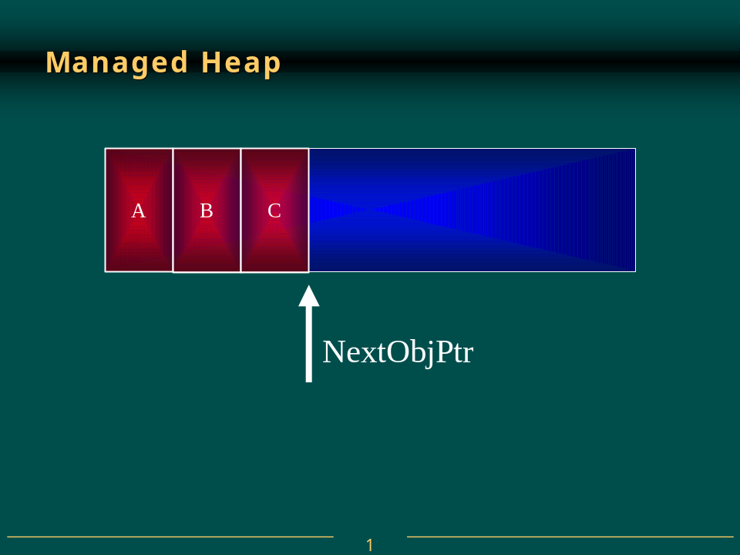
As you can see, allocating objects in the managed heap is generally much faster than allocating objects from a normal C-Runtime heap. In a C-Runtime heap, allocating memory for an object usually requires walking though a linked-list of data structures. Once a large-enough block is found, that block has to be split and pointers in the linked-list nodes must be modified to keep everything in tact. For the managed heap, allocating an object simply means adding a value to a pointer – this is blazingly fast by comparison. In fact allocating an object is nearly as fast as allocating memory from a thread’s stack!
So far, it sounds like the managed heap is far superior to the C-Runtime heap due to its simplicity of implementation and speed. Of course, the managed heap gains these advantages because it makes one really big assumption: address space and storage are infinite. This assumption is, without a doubt, ridiculous and there must be a mechanism employed by the managed heap that allows the heap to make this assumption. This mechanism is the garbage collector and now we’ll discuss how it works.
When an application calls the new operator to create an object, there may not be enough address space left in the region to allocate to the object. The heap detects this by adding the size of the new object to NextObjPtr. If NextObjPtr is beyond the end of the address space region, then the heap is full and a garbage collection (GC) must be performed. In addition, to improve performance, large objects (of 20,000 bytes or more) are allocated from a large object heap whose objects are not collected.

The Garbage Collection Algorithm
The garbage collector checks if there are any objects in the heap that are no longer being used by the application. If such objects exist, then the memory used by these objects can be reclaimed. (If no more memory is available for the heap, then new throws an OutOfMemoryException.) How does the GC know if the application is using an object or not? As you might imagine, this is not a simple question to answer.
Every application has a set of Roots. Roots identify storage locations, which refer to objects on the managed heap or are set to null. For example, all the global and static object pointers in an application are considered to be part of the application’s roots. In addition, any local variable/parameter object pointers on a thread’s stack are also considered part of the application’s roots. Finally, any CPU registers containing pointers to objects in the managed heap are also considered part of the application’s roots. The list of active roots is maintained by the JIT compiler and is made accessible to the garbage collector’s algorithm.
When the garbage collector starts running, it makes the assumption that all objects in the heap are garbage. In other words, it assumes that none of the application’s roots refer to any objects in the heap. Now, the GC starts walking the roots building a graph of all objects reachable from the roots. For example, the GC may locate a global variable that points to an object in the heap. Figure 2 shows a heap with several allocated objects where the application’s roots refer directly to objects A, C, D, F, and H. All these objects become part of the graph. When adding object D, the GC will notices that this object refers to object H and object H is also added to the graph. The GC continues to walk through all reachable objects recursively.
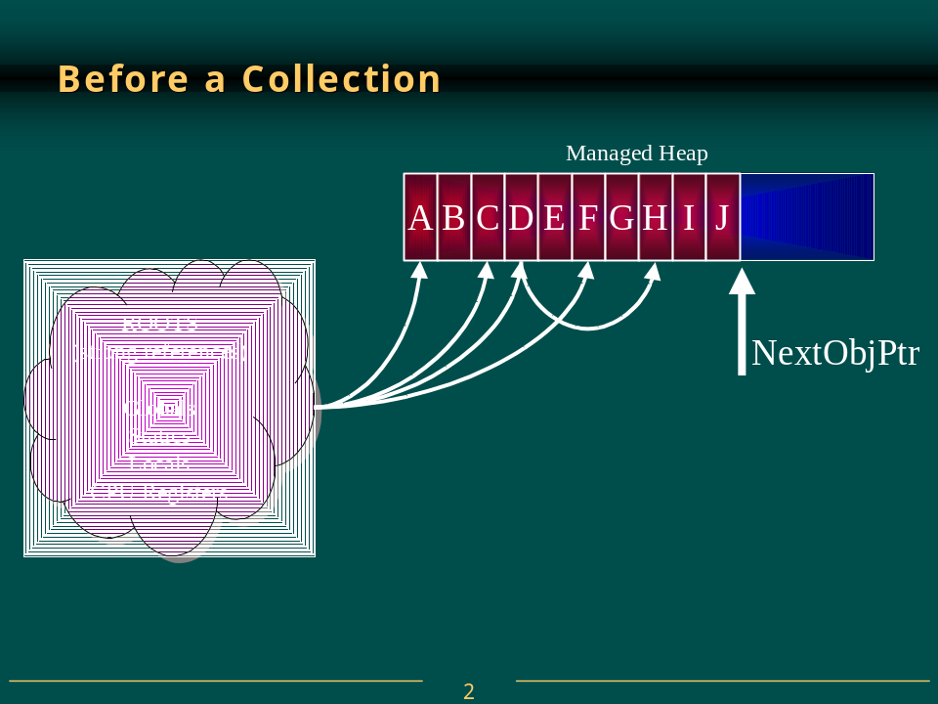
Once this part of the graph is complete, the GC checks the next root and walks the objects again. As the GC walks from object to object, if it attempts to add an object to the graph that it previously added, then the GC can stop walking down that path. This serves two purposes. First, it helps performance significantly since it doesn’t walk through a set of objects more than once. Second, it prevents infinite loops should you have any circular linked-lists of objects.
Once all the roots have been checked, the GC’s graph contains the set of all objects that are somehow reachable from the application’s roots; any objects that are not in the graph are not accessible by the application and are therefore garbage. The GC now walks through the heap linearly looking for contiguous blocks of garbage objects (now considered free space). The GC than shifts the non-garbage objects down in memory (using the standard memcpy function that we’ve known for years) removing all of the gaps in the heap. Of course, moving the objects in memory invalidates all pointers to the objects. So, the GC must modify the application’s roots so that the pointers point to the objects’ new locations. In addition, if any object contains a pointer to another object, the GC is responsible for correcting these pointers as well. Figure 3 shows the managed heap after a collection.
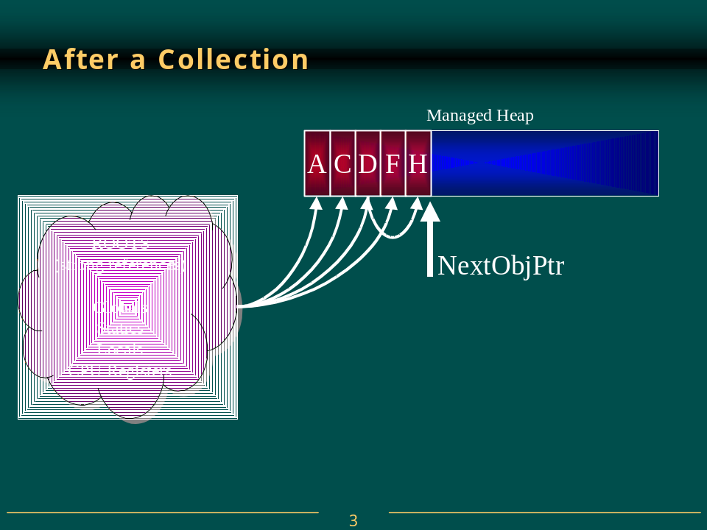
Now, after all the garbage has been identified and after all the non-garbage has been compacted, and after all the non-garbage pointers have been fixed-up, the NextObjPtr is positioned just after the last non-garbage object. At this point, the new operation is tried again and the resource wanted by the application is successfully created.
As you can see, a garbage collection generates a very significant performance hit and this is the major downside of using a managed heap. However, keep in mind that GCs only occur when the heap is full and until then, the managed heap is significantly faster than a C-Runtime heap. Finally, the runtime’s GC offers some optimizations that greatly improve the performance of garbage collection. I’ll discuss these optimizations later when I talk about generations.
The important things to note is that you no longer have to implement any code that manages the lifetime of any resources your application uses. And, notice how the two bugs we discussed at the beginning of this chapter no longer exist. First, it is not possible to leak resources since any resource not accessible from your application’s roots can be collected at some point. Second, it is not possible to access a resource that is freed since the resource won’t be freed if it is reachable and if it’s not reachable then your application has no way to access it.
The code below demonstrates how resources are allocated and managed:
class Application {
public static int Main(String[] args) {
// ArrayList object created in heap, a is now a root
ArrayList a = new ArrayList();
// Create 10000 objects in the heap
for (int x = 0; x < 10000; x++) {
a.Add(new Object()); // Object object created in heap
}
// Right now, a is a root (on the thread’s stack).
// So, a is reachable and the 10000 objects it points to are also reachable.
Console.WriteLine(a.Length);
// After the last reference to a in the code, a is not a root.
// Note that the method doesn’t have to return, the JIT compiler knows
// to make a not a root after the last reference to it in the code.
// Since a is not a root, all 10001 objects are not reachable
// and are considered garbage. However, the objects are not
// collected until a GC is performed.
}
}
If garbage collection is so great, you might be wondering why it isn’t in ANSI C++. The reason is because garbage collection must be able to identify an application’s roots and must also be able to find all objects’ pointers. The problem with C++ is that is allows casting a pointer form one type to another and there’s no way to know what a pointer refers to. In NGWS, a type cannot be arbitrarily cast from one type to any other type and the metadata information is used to determine which members of an object refer to other objects.

Finalization
At this point, you have the basic understanding of garbage collection and the managed heap. However, the garbage collector offers an additional feature that you may want to take advantage of: Finalization. Finalization allows a resource to gracefully cleanup after itself when it is being collected.
Here is an oversimplification of what happens: When the GC detects that an object is garbage, the GC calls the object’s Finalize method (if it exists) and then, the object’s memory is reclaimed. For example, let’s say we have the following class (in C♯):
public class BaseObj {
public BaseObj() {
}
protected override void Finalize() {
Console.WriteLine(“In Finalize.”);
}
}
Now, you create an instance of this object by calling:
BaseObj bo = new BaseObj();
Some time in the future, the garbage collector will determine that this object is garbage. When that happens, the GC will see that the class has a Finalize method, will call the method, causing “In Finalize” to appear in the console window and will then reclaim the memory block used by this object.
If you’re used to programming in C++, many developers draw an immediate correlation between a destructor and the Finalize method. However, let me warn you right now: object finalization and destructors have very different semantics and it is best to forget everything you know about destructors when thinking about finalization. Managed objects never have destructors – period.
When designing a class it is best to avoid using a Finalize method. There are several reasons for this:
- Finalizable objects take longer to allocate.
- Forcing the GC to execute a Finalize method can hurt performance significantly. Remember, each object is finalized. So, if I have an array of 10000 objects, each object must have its Finalize method called.
- A finalizable object may refer to other (non-finalizable) objects prolonging their lifetime unnecessarily. In fact, you might want to consider breaking a type into two different types: a light-weight type with a Finalize method that doesn’t refer to any other objects and a separate type without a Finalize method that does refer to other objects.
- You have no control over when the Finalize method will execute. The object may hold on to resources until the next time the garbage collector runs.
- The runtime makes no guarantee that an object’s Finalize method will ever execute. For example, when an application terminates, many objects are still reachable and will not have their Finalize method called. In addition, Finalize methods are not called for unreachable objects when an application exists so that the application may terminate quickly. Of course, all operating system resources will be reclaimed but any objects in the managed heap are not able to cleanup gracefully. You can change this default behavior by calling the System.GC class’s RequestFinalizeOnShutdown method. However, calling this method is discouraged; it is best to let the application die as quickly as possible. Even if you do call this method, the system allows just 2 seconds for each Finalize method to run.
- The runtime doesn’t make any guarantees as to the order in which Finalize methods are called. For example, let’s say there is an outer object that contains a pointer to an inner object. The GC has detected that both objects are garbage. Let’s further say that the inner object’s Finalize method gets called first. Now, the outer object’s Finalize method is allowed to access the inner object and call methods on it but the inner object has been finalized and the results may be unpredictable. For this reason, it is strongly recommended that Finalize methods not access any inner objects.
If you determine that your class must implement a Finalize method, then make sure that the code executes as quickly as possible. Avoid all actions that would block the Finalize method including any thread synchronization operations. Also, if you let any exceptions escape the Finalize method, the system just assumes that the Finalize method returned and continues calling other object’s Finalize methods.
When the compiler generates code for a constructor, the compiler automatically inserts a call to the base class’s constructor. Likewise, when a C++ compiler generates code for a destructor, the compiler automatically inserts a call to the base class’s destructor. However, we again see that Finalize methods are different from destructors. The compiler has no special knowledge about a Finalize method. So, the compiler does not automatically generate code to call a base class’s Finalize method. If you want this behavior, and frequently you do, then you must explicitly call the base class’s Finalize method from your class’s Finalize method, like this:
public class BaseObj {
public BaseObj() {
}
protected override void Finalize() {
Console.WriteLine(“In Finalize.”);
base.Finalize(); // Call base class’s Finalize
}
}
Note, that you’ll usually call the base class’s Finalize method as the last statement in the derived class’s Finalize method. This keeps the base object “alive” as long as possible. Since calling a base class Finalize method is common, C♯ has a syntax that simplifies your work. In C♯, the following code
class MyObject {
~MyObject() {
...
}
}
causes the compiler to generate the following code:
class MyObject {
protected override void Finalize() {
...
base.Finalize();
}
}
Note that this C♯ syntax looks identical to the C++ language’s syntax for defining a destructor. But remember, C♯ doesn’t support destructors. Don’t let the identical syntax fool you.

Finalization Internals
On the surface, finalization seems quite forward; you create an object, when the object is collected, the object’s Finalize method is called. But there is more to finalization than this.
When an application creates a new object, the new operator allocates the memory from the heap. If the object’s class contains a Finalize method, then a pointer to the object is placed on the finalization queue. The finalization queue is an internal data structure controlled by the garbage collector. Each entry in the queue points to an object that should have its Finalize method called before the object’s memory can be reclaimed.
Figure 4 shows a heap containing several objects. Some of these objects are reachable from the application’s roots and some are not. When objects C, E, F, I, and J were created, the system detected that these objects had Finalize methods and pointers to these objects were added to the finalization queue.
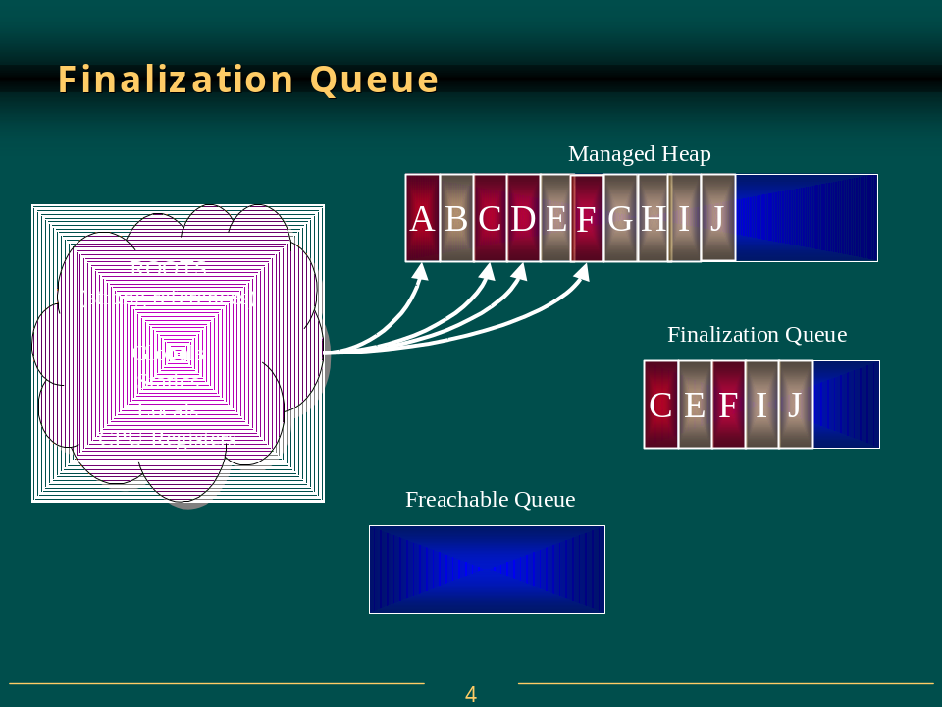
When a GC occurs, objects B, E, G, H, I, and J are determined to be garbage. The GC scans the finalization queue looking for pointers to these objects. When a pointer is found, the pointer is removed from the finalization queue and appended to the freachable queue. The freachable queue (pronounced F-reachable) is another internal data structure controlled by the garbage collector. Each pointer in the freachable queue identifies an object that is ready to have its Finalize method called. After the collection, the managed heap looks like Figure 5.
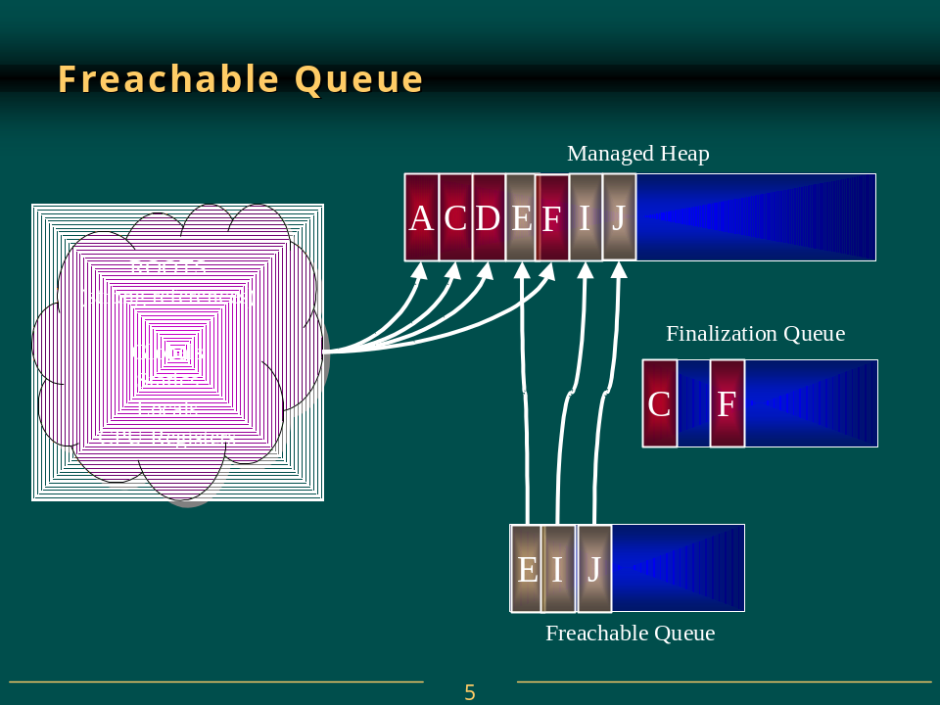
Here, you see that the memory occupied by objects B, G, and H has been reclaimed because these objects did not have a Finalize method that needed to be called. However, the memory occupied by objects E, I, and J cold not be reclaimed because their Finalize method has not been called yet.
There is a special runtime thread dedicated to calling Finalize methods. When the freachable queue is empty (the usual case), this thread sleeps. But, when entries appear, this thread wakes, removes each entry from the queue and calls each object’s Finalize method. Because of this, you should not execute any code in a Finalize method that makes any assumption about the thread that’s executing the code. For example, avoid accessing thread local storage in the Finalize method.
The interaction of the finalization queue and the freachable queue is quite fascinating. First, let me tell you how the freachable queue got its name. Well, the “f” is obvious and stands for finalization: every entry in the freachable queue should have its Finalize method called. But, the “reachable” part of the name means that the objects are reachable. To put it another way, the freachable queue is considered a root just like global and static variables are roots. So, if an object is on the freachable queue, then the object is reachable and is not garbage.
In summary, when an object is not reachable, the GC considers the object garbage. Then, when the GC moves an object’s entry from the finalization queue to the freachable queue, the object is no longer considered garbage and its memory is not reclaimed. At this point, the GC has finished identifying garbage. Some of the objects identified as garbage have been reclassified as not garbage. The GC compacts the reclaimable memory and the special runtime thread empties the freachable queue executing each object’s Finalize method.
Now, the next time the GC is invoked, it sees that the finalized objects are truly garbage since the application’s roots don’t point to it and the freachable queue no longer points to it. Now, the memory for the object is simply reclaimed. The important thing to get from all of this is that two garbage collections are required to reclaim memory used by objects that require finalization. In reality more than 2 collections may be necessary since the objects could get promoted to an older generation (discussed later). Figure 6 shows what the managed heap looks like after the second garbage collection.
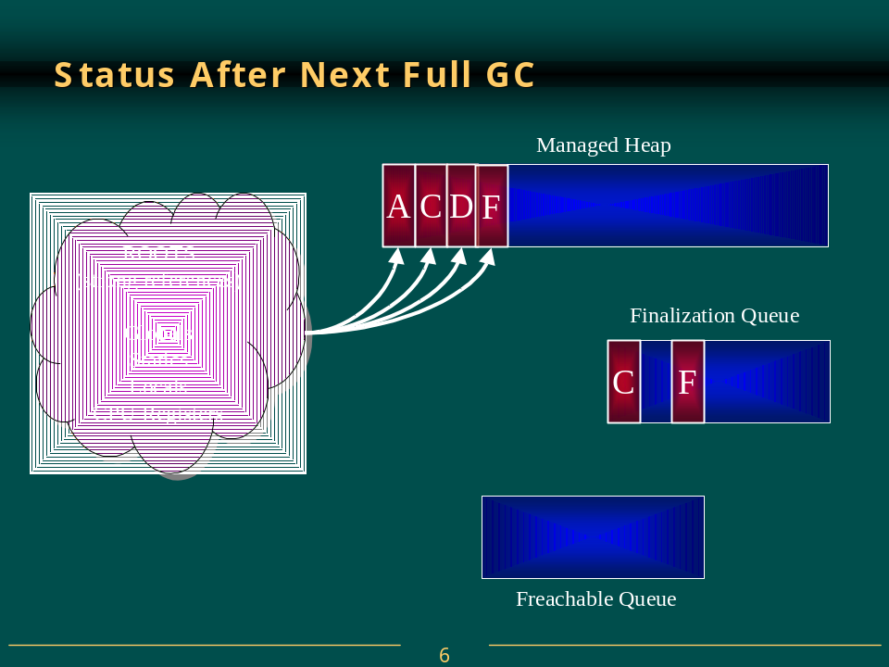

Resurrection
I’m sure you agree that finalization is fascinating. However, there is more to it than what I’ve already described. Since an object requiring finalization dies, lives, and then dies again, a very interesting phenomenon is possible: resurrection. Resurrection, as its name implies, allows an object to come back from the dead.
We’ve already seen a form of resurrection. When the GC places a reference to the object on the freachable queue, the object is reachable from a root and has come back to life. Eventually, the object’s Finalize method is called, no roots point to the object and the object is dead forever after. But, what if an object’s Finalize method executed code that placed a pointer to the object in a global or static variable. For example,
public class BaseObj {
protected override void Finalize() {
Application.ObjHolder = this;
}
}
class Application {
static public Object ObjHolder; // Defaults to null
.
.
.
}
In this case, when the object’s Finalize method executes, a pointer to the object is placed in a root and the object is reachable from the application’s code. This object is now resurrected and the GC will not consider the object to be garbage. The application is free to use the object but it is very important to note that the object has been finalized and using the object may cause unpredictable results. Also note: if BaseObj contained members that pointed to other objects, all objects would be resurrected since they are all reachable from the application’s roots. However, be aware that some of these other objects may also have been finalized.
Now, if some other piece of code sets Application.ObjHolder to null, the object is unreachable. Eventually the GC will consider the object to be garbage and will reclaim the object’s storage. Note that the object’s Finalize method will not be called because no pointer to the object exists on the finalization queue.
There are very few good uses of resurrection and you really should avoid it if possible. However, when people do use resurrection, they usually do want the object to gracefully clean itself up every time the object dies. To make this possible, the GC class offers a method called ReRegisterForFinalize, which takes a single parameter, the pointer to an object. Examine the following code:
public class BaseObj {
protected override void Finalize() {
Application.ObjHolder = this;
GC.ReRegisterForFinalize(this);
}
}
When this object’s Finalize method is called, it resurrects itself by making a root point to the object. The Finalize method then calls ReRegisterForFinalize, which appends the address of the specified object (this) to the end of the finalization queue. When the GC detects that this object is unreachable again, it will queue the object’s pointer on the freachable queue and the Finalize method will get called again.
This specific example shows how to create an object that constantly resurrects itself and never dies. This is usually not desirable. It is far more common to conditionally set a root to reference the object inside the Finalize method.
Make sure that you call ReRegisterForFinalize no more than once per resurrection or the object will have its Finalize method called multiple times. The reason is because each call to ReRegisterForFinalize appends a new entry to the end of the finalization queue. When an object is determined to be garbage, all of these entries move from the finalization queue to the freachable queue calling the object’s Finalize method multiple times.

Forcing an Object to Cleanup
If you can, you should try to define objects that do not require any cleanup. Unfortunately, for many objects, this is simply not possible. So, for these objects, you must implement a Finalize method as part of the class’s definition. However, it is also recommended that you add an additional method to the class that allows a user of the class to explicitly cleanup the object when they desire. By convention, this method should be called Dispose. However, if the object is generally considered to be closed when no longer needed (such as a file), then the method should be called Close instead of Dispose.
For example, the System.IO.FileStream class allows the user to open a file for reading and writing. To improve performance, the class’s implementation makes use of a memory buffer. Only when the buffer fills does the class flush the contents of the buffer to the file. Now, let’s say that you create a new FileStream object and write just a few bytes of information to it. If these bytes don’t fill the buffer, then the buffer is not written to disk. It’s true, the FileStream class does implement a Finalize method and when the FileStream object is collected, the Finalize method flushes any remaining data from memory to disk and then closes the file.
But, this approach may not be good enough for the user of the FileStream class. Let’s say that the first FileStream object has not been collected yet but the application wants to create a new FileStream object using the same disk file. In this scenario, the second FileStream object will fail to open the file if the first FileStream object had the file open for exclusive access. The user of the FileStream object must have some way to force the final memory flush to disk and to close the file.
If you examine the FileStream object’s documentation, you’ll see that it has a method called Close. When called, this method flushes the remaining data in memory to the disk and closes the file. Now, the user of a FileStream object has complete control of the object’s behavior.
But, an interesting problem arises now: what should the FileStream’s Finalize method do when the FileStream object is collected? Obviously, the answer is “nothing.” In fact, there is no reason for the FileStream’s Finalize method to execute at all if the application has explicitly called the Close method. We know that Finalize methods are discouraged and in this scenario, we’re going to have the system call a Finalize method that should do nothing. Seems like there ought to be a way to suppress the system calling the object’s Finalize method. Fortunately, there is. The System.GC class contains a static method, SuppressFinalize that takes a single parameter, the address of an object.
Here is what the FileStream object’s implementation looks like:
public class FileStream : Stream {
public override void Close() {
// Cleanup this object: flush data and close file
.
.
.
// There is no reason to Finalize this object now
GC.SuppressFinalize(this);
}
protected override void Finalize() {
Close(); // Cleanup this object: flush data and close file
}
// Rest of FileStream methods go here
.
.
.
}
When you call SuppressFinalize, it turns on a bit flag associated with the object. When this flag is on, the runtime knows not to move this object’s pointer to the freachable queue, preventing the object’s Finalize method from being called.
Let’s examine another issue related to this. It is very common to use a StreamWriter object with a FileStream object. The following code demonstrates:
FileStream fs = new FileStream(“C:\\SomeFile.txt”,
FileMode.Open, FileAccess.Write, FileShare.Read);
StreamWriter sw = new StreamWriter(fs);
sw.Write (“Hi there”);
// The call to Close below is what you should do
sw.Close();
// NOTE: StreamWriter.Close closes the FileStream. The FileStream
// should not be explicitly closed in this scenario
Notice that the StreamWriter’s constructor takes a FileStream object as a parameter. Internally, the StreamWriter object saves the FileStream’s pointer. Both of these objects have internal data buffers that should be flushed to the file when we’re done accessing the file. Calling the StreamWriter’s Close method writes the final data to the FileStream and internally calls the FileStream’s Close method, which writes the final data to the disk file and closes the file. Since StreamWriter’s Close method closes the FileStream object associated with it, you should not call fs.Close yourself.
What do you think would happen if we removed the two calls to Close? Well, the GC would correctly detect that the objects are garbage and the objects would get finalized. But, the GC doesn’t guarantee the order in which the Finalize methods are called. So, if the FileStream gets finalized first, it closes the file. Then, when the StreamWriter get finalized, it would attempt to write data to the closed file, raising an exception. Of course, if the StreamWriter got finalized first, then the data would be safely written to the file.
How was Microsoft to solve this problem? Making the GC finalize objects in a specific order is impossible because objects could contain pointers to each other and there is no way for the GC to correctly guess the order to finalize these objects. So, here is Microsoft’s solution: the StreamWriter class doesn’t implement a Finalize method at all. Of course, this means that forgetting to explicitly close the StreamWriter object means that data is guaranteed to be lost. Microsoft expects the developer will see this consistent loss of data and will fix the code by inserting an explicit call to Close.
As stated earlier, the SuppressFinalize method simply sets a bit flag indicating that the object’s Finalize method should not be called. However, this flag is reset when the runtime determines that it’s time to call a Finalize method. This means that calls to ReRegisterForFinalize cannot be balanced by calls to SuppressFinalize. The code below demonstrates exactly what I mean:
void method() {
// The MyObj class has a Finalize method defined for it
// Creating a MyObj places a reference to obj on the finalization table.
MyObj obj = new MyObj();
// Append another 2 references for obj onto the finalization table.
GC.ReRegisterForFinalize(obj);
GC.ReRegisterForFinalize(obj);
// There are now 3 references to obj on the finalization table.
// Have the system ignore the first call to this object’s Finalize method.
GC.SuppressFinalize(obj);
// Have the system ignore the first call to this object’s Finalize method.
GC.SuppressFinalize(obj); // In effect, this line does absolutely nothing!
obj = null; // Remove the strong reference to the object.
// Force the GC to collect the object.
GC.Collect();
// The first call to obj’s Finalize method will be discarded but
// two calls to Finalize are still performed.
}
ReRegisterForFinalize and SuppressFinalize are implemented the way they are for performance reasons. As long as each call to SuppressFinalize has an intervening call to ReRegisterForFinalize, everything works as expected. It is up to you to ensure that you do not call ReRegisterForFinalize or SuppressFinalize multiple times consecutively or multiple calls to an object’s Finalize method can occur.

Weak References
When a root points to an object, the object cannot be collected because the application’s code can reach the object. When a root points to an object, we say that there exists a strong reference to the object. However, the garbage collector also supports weak references. Weak references allow the GC to collect the object but they also allow the application to access the object. It all comes down to timing.
If only weak references to an object exist and the GC runs, the object is collected and, when the application later attempts to access the object, the access will fail. On the other hand, to access a weakly-referenced object, the application must obtain a strong reference to the object. If the application obtains this strong reference before the GC collects the object, then the GC can’t collect the object because a strong reference to the object exists.
I know this all sounds somewhat confusing so let’s clear it up by examining some code:
Void Method() {
Object o = new Object(); // Creates a strong reference to the object.
// Create a strong reference to a short WeakReference object.
// The WeakReference object tracks the Object.
WeakReference wr = new WeakReference(o);
o = null; // Remove the strong reference to the object
o = wr.Target;
if (o == null) {
// A GC occurred and Object was reclaimed.
} else {
// a GC did not occur and we can successfully access the Object using o
}
}
Why might you use weak references? Well, there are some data structures that are created easily but require a lot of memory. For example, you might have an application that needs to know all the directories and files on the user’s hard drive. You can easily build a tree that reflects this information and as your application runs, you’ll refer to the tree in memory instead of actually accessing the user’s hard disk. This greatly improves the performance of your application.
The problem is that the tree could be extremely large requiring quite a bit of memory. If the user starts accessing a different part of your application, the tree may no longer be necessary and is wasting valuable memory. You could delete the tree but if the user switches back to the first part of your application, you’ll need to reconstruct the tree again. Weak references allow you to handle this scenario quite easily and efficiently.
When the user switches away from the first part of the application, you can create a weak reference to the tree and destroy all strong references. If the other subcomponent’s memory load is low, then the GC will not reclaim the tree’s objects. When the user switches back to the first component, the application attempts to obtain a strong reference for the tree. If successful, the application doesn’t have to traverse the user’s hard drive again.
The WeakReference type offers two constructors:
WeakReference(Object target);
WeakReference(Object target, Boolean trackResurrection);
The target parameter identifies the object that the WeakReference object should track. The trackResurrection parameter indicates whether the WeakReference object should track the object after it has had its Finalize method called. Usually, false is passed for the trackResurrection parameter and the first constructor creates a WeakReference that does not track resurrection.
For convenience, a WeakReference that does not track resurrection is called a short weak reference while a WeakReference that does track resurrection is called a long weak reference. If an object’s type doesn’t offer a Finalize method, then short and long weak references behave identically. It is strongly recommended that you avoid using long weak references. Long weak references allow you to resurrect an object after it has been finalized and the state of the object is unpredictable.
Once you’ve created a weak reference to an object, you usually set the strong reference to the object to null. If any strong reference remains, the garbage collector will be unable to collect the object.
To attempt to access a weakly-referenced object, you simply assign the value in the WeakReference object’s Target property to one of your application’s root. If the Target property returns null, then the object was collected. If the property does not return null, then the root is a strong reference to the object and the code may manipulate the object. As long as the strong reference exists, the object cannot be collected.

Weak Reference Internals
From the discussion above, it should be obvious that WeakReference objects do not behave like other object types. Normally, if your application has a root that refers to an object and that object refers to another object, then both objects are reachable and the GC cannot reclaim the memory in use by either object. However, if your application has a root that refers to a WeakReference object, then the object referred to by the WeakReference object is not considered reachable and may be collected.
To fully understand how weak references work we’ll have to look inside the managed heap again. The managed heap contains two internal data structures whose sole purpose is to manage weak references: the short weak reference table and the long weak reference table. These two tables simply contain pointers to objects allocated within the managed heap.
Initially, both tables are empty. When you create a WeakReference object, an object is not allocated from the managed heap. Instead, an empty slot in one of the weak reference tables is located; short weak references use weak reference table and long weak references use the long weak reference table.
Once an empty slot is found, the value in the slot is set to the address of the object you wish to track – the object’s pointer is passed to the WeakReference’s constructor. The value returned from the new operator is the address of the slot in the WeakReference table. Obviously, the two weak reference tables are not considered part of an application’s roots or the GC would not be able to reclaim the objects pointed to by the tables.
Now, here’s what happens when a GC runs:
- The GC builds a graph of all the reachable objects. We’ve already discussed how the GC does this.
- The GC scans the short weak reference table. If a pointer in the table refers to an object that is not part of the graph, then the pointer identifies an unreachable object and the slot in the short weak reference table is set to null.
- The GC scans the finalization queue. If a pointer in the queue refers to an object that is not part of the graph, then the pointer identifies an unreachable object and the pointer is moved from the finalization queue to the freachable queue. At this point, the object is added to the graph since the object is now considered reachable.
- The GC scans the long weak reference table. If a pointer in the table refers to an object that is not part of the graph (which now contains the objects pointed to by entries in the freachable queue), then the pointer identifies an unreachable object and the slot is set to null.
- The GC compacts the memory, squeezing out the holes left by the unreachable objects.
Once you understand the logic above, it’s easy to understand how weak references work. Accessing the WeakReference’s Target property causes the system to return the value in the appropriate weak reference table’s slot. If null is in the slot, the object was collected.
A short weak reference doesn’t track resurrection. This means that the GC sets the pointer to null in the short weak reference table as soon as the GC has determined the object to be unreachable. If the object has a Finalize method, the method has not been called yet so the object still exists. If the application accesses the WeakReference object’s Target property, then null will be returned even though the object actually still exists.
A long weak reference tracks resurrection. This means that the GC sets the pointer to null in the long weak reference table when the object’s storage is reclaimable. If the object has a Finalize method, the Finalize method has been called and the object was not resurrected.

Generations
When I first started working in a garbage-collected environment, I had many concerns about performance. After all, I’ve been a C/C++ programming for over 15 years and I understand the overhead of allocating and freeing memory blocks from a heap. Sure, each version of Windows and each version of the C-Runtime has tweaked the internals of the heap algorithms in order to improve performance. But, basically, I understand what’s happening. On the other hand, before researching the GC, the GC seemed like a big black hole to me that magically managed my memory.
Well, like the Windows and C-Runtime developers, the GC developers are tweaking the GC to improve its performance too. One feature of the GC that exists purely to improve performance is called generations. A generational garbage collector (also known as an ephemeral garbage collector) makes the following assumptions:
- The newer an object is, the shorter its lifetime will be.
- The older an object is, the longer its lifetime will be.
- Newer objects tend to have strong relationships to each other and are frequently accessed around the same time.
- Compacting a portion of the heap is faster than compacting the whole heap.
Of course, many studies have been done demonstrating that these assumptions are valid for a very large set of existing applications. So now, let’s discuss how these assumptions have influenced the implementation of the GC.
When initialized, the managed heap contains no objects. Objects added to the heap are said to be in Generation 0. Stated simply, objects in Generation 0 are young objects that have never been examined by the GC.

Now if more objects are added to the heap, the heap fills and a GC must occur. When the GC analyzes the heap, it builds the graph of garbage and non-garbage objects. Any objects that survive the collection are compacted into the left-most portion of the heap. These objects have survived a collection, are older, and are now considered to be in Generation 1.
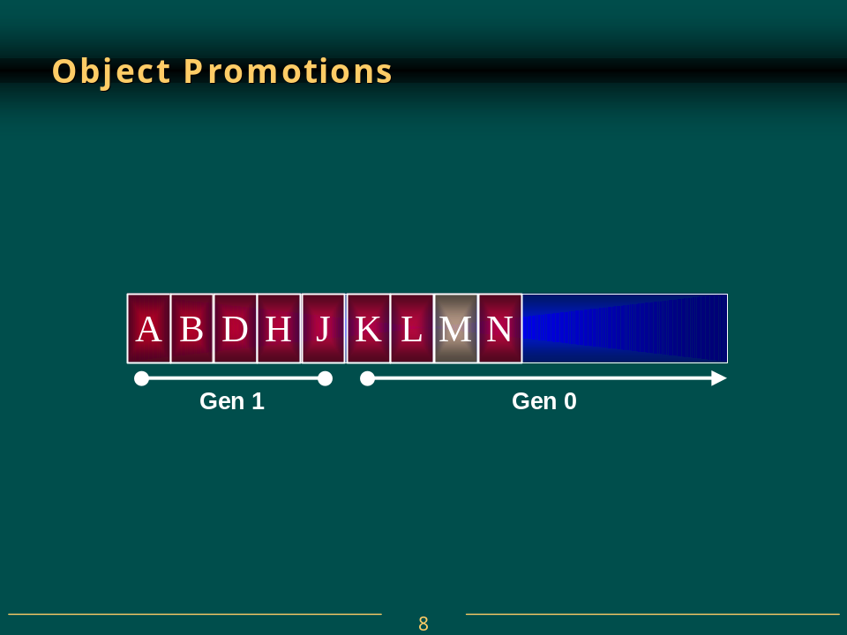
As even more objects are added to the heap, these new, young objects are placed in generation 0. If the heap fills again, a GC is performed. This time, all objects in generation 1 that survive are compacted and considered to be in generation 2. All survivors in generation 0 are now compacted and in generation 1. Generation 0 currently contains no objects but all new objects will go into generation 0.
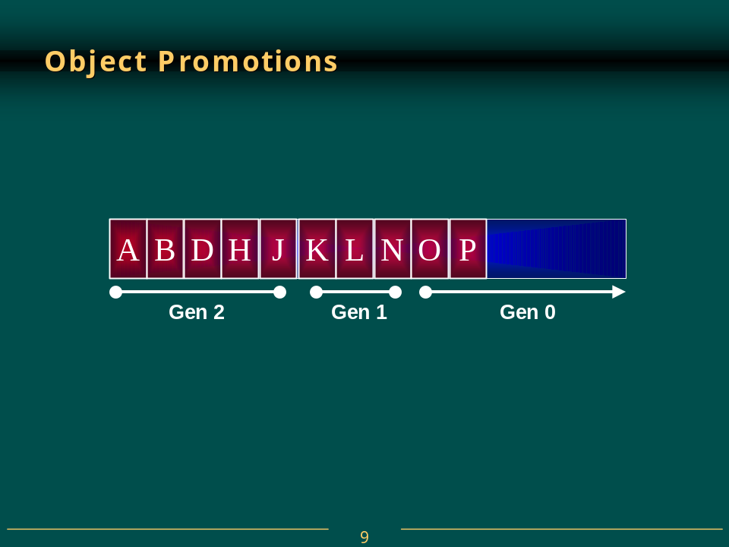
Currently, generation 2 is the highest generation supported by the NGWS runtime’s garbage collector. When future collections occur, any surviving objects currently in generation 2, simply stay in generation 2.
As stated above, generational garbage collecting improves performance. When the heap fills and a GC occurs, the GC can choose to examine only the objects in generation 0 and ignore the objects in any greater generations. After all, the newer an object is, the shorter its lifetime is expected to be. So, collecting and compacting generation 0 objects is likely to reclaim a significant amount of space from the heap and be faster about it than if the collector had examined the objects in all generations.
This is the simplest optimization that can be obtained from generational GC. However, a generational collector can offer more optimizations by not traversing every object in the managed heap. If a root or object refers to an object in an old generation, the GC can ignore any of the older objects’ inner references decreasing the time required to build the graph of reachable objects. Of course it is possible that an old object refers to a new object. So that these objects are examined, the collector can take advantage of the system’s write-watch support (provided by Win32’s GetWriteWatch function in Kernel32.dll). This support lets the collector know which old objects (if any) have been written to since the last collection. These specific old object’s can have their references checked to see if they refer to any new objects.
If collecting generation 0 doesn’t provide the necessary amount of storage, then the collector can attempt to collect the objects from generations 1 and 0. If all else fails, then the collector can collect the objects from all generations, 2, 1, and 0. The exact algorithm used by the collector for determining which generations to collect is one of those areas that Microsoft will be tweaking forever.
There is one more performance issue that is worth noting. Most heaps (like the C-Runtime heap) allocate objects wherever they find free space. Therefore, if I create several objects consecutively, it is quite possible that these objects will be separated by megabytes of address space. However, in the managed heap, allocating several objects consecutively ensures that the objects are contiguous in memory.
One of the assumptions stated earlier, was that newer objects tend to have strong relationships to each other and are frequently accessed around the same time. Since new objects are allocated contiguously in memory, you gain performance from locality of reference. More specifically, this means that it is highly likely that all the objects can reside in the CPUs cache. Your application will access these objects with phenomenal speed since the CPU will be able to perform most of its manipulations without having cache misses forcing RAM access.
Microsoft’s performance tests show that managed heap allocations are faster than standard allocations performed by the Win32 HeapAlloc function. These tests also show that it takes less than 1 millisecond on a 200 MHz Pentium to perform a full garbage collection of Generation 0. It is Microsoft’s goal to make garbage collections take no more time than an ordinary page fault.
The System.GC class allows your application some direct control over the garbage collector. For starters, you can query the maximum generation supported by the managed heap by reading the GC.MaxGeneration property. Currently, this property always returns 2.
You can also force the garbage collector to perform a collection by calling one of the following two methods:
void GC.Collect(Int32 Generation)
void GC.Collect()
The first method allows you to specify which generation to collect. You may pass any integer from 0 to GC.MaxGeneration inclusive. Passing 0 causes generation 0 to be collected, passing 1 causes generation 1 and 0 to be collected, and passing 2 causes generation 2, 1, and 0 to be collected. The version of the Collect method that takes no parameters forces a full collection of all generations and is equivalent to calling:
GC.Collect(GC.MaxGeneration);
Under most circumstances, you should avoid calling any of the Collect methods; it is best to just let the garbage collector run on its own accord. However, since you application knows more about its behavior then the runtime does, you could “help” matters by explicitly forcing some collections. For example, it might make sense for your application to force a full collection of all generations after the user saves their data file. Internet Explorer performs a full collection when it unloads a page. You might also want to force a collection when your application is performing other lengthy operations; this hides the time required by the collection so that a collection doesn’t occur when the user is interacting with your application.
The GC class also offers a WaitForPendingFinalizers method. This method simply suspends the calling thread until the thread processing the freachable queue has emptied the queue, calling each object’s Finalize method. In most applications, it is unlikely that you will ever have to call this method.
Lastly, the GC offers two methods that allow you to determine which generation an object is currently in:
Int32 GetGeneration(Object obj)
Int32 GetGeneration(WeakReference wr)
The first version of GetGeneration takes an object reference as a parameter and the second version takes a WeakReference reference as a parameter. Of course, the value returned will be between 0 and GC.MaxGeneration inclusively.

Garbage Collector Performance Issues
In the previous section, I explained the garbage collection algorithm. However, there was a big assumption made during the discussion: only one thread is running. In the real world, it is quite likely that multiple threads will be accessing the managed heap or at least manipulating objects allocated within the managed heap. When one thread sparks a collection, other threads must not access any objects (including object references on its own stack) since the collector is likely to move these objects changing their memory locations.
So, when the garbage collector wants to start a collection, all threads executing managed code must be suspended. The runtime has a few different mechanisms that it uses to safely suspend threads so that a collection may be done. The reason why there are multiple mechanisms is to keep threads running as long as possible and to reduce overhead as much as possible. I do not want to get into all the details here but suffice it to say that Microsoft has done a lot of work to reduce the overhead involved with doing a collection. And, Microsoft will continue to modify these mechanisms over time to ensure efficient garbage collections.
Here are some of the mechanisms that the garbage collector employs:
- Fully Interruptible Code. When a collection starts, the collector suspends all application threads. The collector then determines where a thread got suspended and using tables produced by the JIT compiler, the collector can tell where in a method the thread stopped, what object references the code is currently accessing and where those references are held (variable, CPU register, etc).
- Hijacking. The collector can modify a thread’s stack so that the return address points to a special function. When the currently executing method returns, this special function will execute, suspending the thread. Stealing the thread’s execution path this way is referred to as hijacking the thread. When the collection is complete, the thread will resume and return to the method that originally called it.
- Safe Points. As the JIT compiler compiles a method, it can insert calls to a special function that checks if a GC is pending. If so, the thread is suspended, the GC runs to completion, and the thread is then resumed. The position where the compiler inserts these method calls is called a GC safe point.
Note that thread hijacking allows threads executing unmanaged code to continue execution while a garbage collection is occurring. This is not a problem since unmanaged code is not accessing objects on the managed heap unless the objects are pinned and don’t contain object references. A pinned object is one that the garbage collector is not allowed to move in memory. If a thread currently executing unmanaged code returns to managed code, the thread is hijacked and is suspended until the garbage collection completes.
In addition, to the mechanisms mentioned above, the garbage collector offers some additional improvements that improve the performance of object allocations and collections:
- Synchronization-Free Allocations. On a multi-processor system, generation 0 of the managed heap is split into multiple memory arenas; one arena per thread. This allows multiple threads to make allocations simultaneously so that exclusive access to the heap is not required.
- Scalable Collections. On a multi-processor system running the server version of the execution engine (MSCorSvr.dll), the managed heap is split into several sections, one per CPU. When a collection is initiated, the collector has one thread per CPU; each thread collects its own section simultaneously. The workstation version of the execution engine (MSCorWks.dll) doesn’t support this feature.
It should be noted that all of these mechanisms are transparent to your application code. To you, the developer, it looks like there is just one managed heap; these mechanisms exist simply to improve application performance.

Monitoring Garbage Collections
The NGWS team has created a set of performance counters that offer a lot of real-time statistics about the runtime’s operations. These statistics are visible via the Windows 2000 System Monitor ActiveX control. The easiest way to access the System Monitor control is to run PerfMon.exe and select the + toolbar button causing the Add Counters dialog box to appear (as shown below).
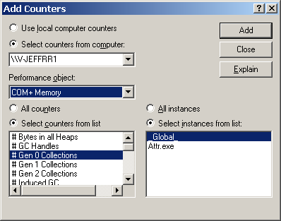
To monitor the runtime’s garbage collector, select the COM+ Memory performance object. Then, you can select a specific application from the instance list box. Finally, select the set of counters that you’re interested in monitoring and press the Add button followed by the Close button. At this point, the System Monitor will graph the selected real-time statistics.
The list below shows each counter with its description:
Counter | Description
# Bytes in all Heaps | Total bytes in heaps for generation 0; 1; and 2 and from the large object heap. This indicates how much memory the garbage collector is using to store allocated objects.
# GC Handles | Total number of current GC Handles.
# Gen 0 Collections | Number of collections of generation 0 <youngest> objects
# Gen 1 Collections | Number of collections of generation 1 objects.
# Gen 2 Collections | Number of collections of generation 2 <older> objects.
# Induced GC | Total number of times the GC was run because of an explicit call (such as from the Classlibs) instead of during an allocation.
# Pinned Objects | Not yet implemented
# of Sink Blocks in use | Synchronization primitives use sink blocks. Sink block data belongs to an Object and is allocated on demand.
# Total committed Bytes | Total committed bytes from all heaps.
% Time in GC | Total time since the last sample spent doing Garbage Collection divided by total time since the last sample.
Allocated Bytes/sec | Rate of Bytes per second allocated by the GC. This is only updated at a Garbage Collection not at each allocation. So since it is a rate time between GCs will be 0.
Finalization Survivors | Number of garbage collected classes that survive because their finalizer creates a reference to them.
Gen 0 heap size | Size of generation 0 (youngest) heap in bytes.
Gen 0 Promoted Bytes/Sec | Bytes per second that are promoted from generation 0 <youngest> to generation 1. Memory is promoted when it survives a garbage collection
Gen 1 heap size | Size of generation 1 heap in bytes.
Gen 1 Promoted Bytes/Sec | Bytes per second that are promoted from generation 1 to generation 2 <oldest>. Memory is promoted when it survives a garbage collection. Nothing is promoted from generation 2 since it is the oldest.
Gen 2 heap size | Size of generation 2 (older) heap in bytes.
Large Object Heap size | Size of the Large Object heap in bytes.
Promoted Memory from Gen 0 | Bytes of memory that survive garbage collection and are promoted from generation 0 to generation 1.
Promoted Memory from Gen 1 | Bytes of memory that survive garbage collection and are promoted from generation 1 to generation 2.

Actually, the heuristics are a little more complex than this, involving looking for naming patterns in the subdirectories as well.
A sealed type cannot be used as the base of a new type.

